Chapter 9. Trunking with LAN Emulation
This chapter covers the following key topics:
- A Brief ATM Tutorial—
For engineers accustomed to working in frame-based technologies such as Ethernet, ATM can seem strange and mysterious. However, as this section discusses, it is based on many of the same fundamental concepts as technologies that are probably more familiar.
- LANE: Theory of Operation—
Introduces the theory used by LAN Emulation (LANE) to simulate Ethernet and Token Ring networks over an ATM infrastructure. Explores the conceptual approach used by LANE and its four main components. This is followed by a detailed description of the LANE initialization sequence and the required overhead connections.
- Configuration Concepts—
Discusses several concepts used to configure LANE on Cisco equipment.
- Configuration Syntax—
Introduces a five-step process that can be used to configure LANE on Cisco routers and Catalyst equipment.
- A Complete LANE Network—
Pulls together the material discussed in previous sections by examining a complete end-to-end LANE configuration in a sample campus network.
- Testing the Configuration—
Explains several useful and important commands used to troubleshoot and maintain LANE networks on Cisco equipment.
- Advanced Issues and Features—
Discusses a variety of advanced LANE topics such as LANE design, Simple Server Redundancy Protocol (SSRP), PVC-based connectivity, and traffic shaping.
Asynchronous Transfer Mode (ATM) has received considerable press and attention since the early 1990s. As one of the original four founders of the ATM Forum (ATMF, or The Forum), Cisco has played a significant role in ATM's development. The ATM Forum has produced a large number of standards aimed at improving the acceptance and interoperability of ATM. By 1996, several key standards were complete and available in commercial products, finally allowing network administrators to build viable networks using ATM. Today, ATM is an extremely feature-rich and high performance technology. Of the several approaches devised by the ATM Forum, LAN Emulation (LANE) has become the most popular for campus data networking.
Before getting started, two cautions are in order. First, ATM is a very complex subject—don't be surprised if it takes a little while to feel comfortable with this new and complex technology. Most users find it very difficult to "ramp up" on ATM. For example, it uses a lot of geeky concepts and acronyms (you will come to learn that ATM really stands for Acronym Training Method). Second, it is impossible to cover everything there is to know about ATM in this chapter. There are obviously many books devoted entirely to the subject. Our purpose is more specific: learn as much as possible about using ATM in the real world to build LANE campus backbones (while also setting the stage for Chapter 10, which covers Multiprotocol over ATM—MPOA).
However, do not despair. Believe it or not, ATM and LANE are subjects that you actually can decipher and understand. By focusing specifically on LANE, this chapter glosses over some of the murkier issues of ATM theory. By discussing it from a real-world perspective, the text avoids the labyrinth of ATM's theoretical questions and issues. By stressing the important concepts, this chapter promises to make you an effective LANE designer, planner, implementer, and troubleshooter.

A Brief ATM Tutorial
This section looks at some basic ATM concepts and terminology before diving into the deep waters of LANE. The principal concepts covered here include the following:
- Understanding ATM Cells (Five Questions about Cells That You Were Always Afraid to Ask)
- ATM is Connection Oriented
- ATM Addressing
- ATM Devices
- ATM Overhead Protocols
- When to Use ATM

Understanding ATM Cells: Five Questions about Cells (That You Were Always Afraid to Ask)
The single most important characteristic of ATM is that it uses cells. Whereas other technologies transport large and variable-length units of data, ATM is completely based around small, fixed-length units of data called cells.

Why Cells?
Most readers are probably aware that ATM uses fixed-length packages of data called cells. But what's the big deal about cells? Because it takes quite a lot of work for network devices hardware to cellify all of their data, what is the payoff to justify all of this extra work and complexity? Fortunately, cells do have many advantages, including the following:
- High throughput
- Advanced statistical multiplexing
- Low latency
- Facilitate multiservice traffic (voice, video, and data)
Each of these advantages of ATM cells is addressed in the sections that follow.

High Throughput
High throughput has always been one of the most compelling benefits of ATM. At the time ATM was conceived, routers were slow devices that required software-based processing to handle the complex variable-length and variable-format multiprotocol (IP, IPX, and so forth) traffic. The variable data lengths resulted in inefficient processing and many complex buffering schemes (to illustrate this point, just issue a show buffers command on a Cisco router). The variable data formats required every Layer 3 protocol to utilize a different set of logic and routing procedures. Run this on a general-purpose CPU and the result is a low-throughput device.
The ATM cell was designed to address both of these issues. Because cells are fixed in length, buffering becomes a trivial exercise of simply carving up buffer memory into fixed-length cubbyholes. Because cells have a fixed-format, 5-byte header, switch processing is drastically simplified. The result: it becomes much easier to build very high-speed, hardware-based switching mechanisms.

Advanced Statistical Multiplexing
Large phone and data carriers funded the majority of early ATM research. One of the key factors that motivated carriers to explore ATM was their desire to improve utilization and statistical multiplexing in their networks. At the time, it was very common (and still is) to link sites using channelized T1 circuits (or E1 circuits outside the United States). Figure 9-1 illustrates a typical use of this approach.

Figure 9-1 A Typical Channelized Network
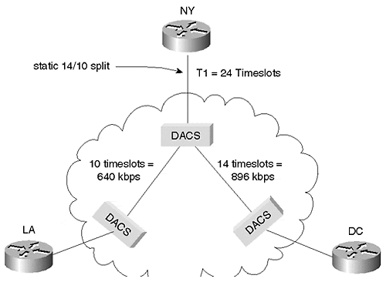
Figure 9-1 illustrates a small corporate network with three sites: headquarters is located in New York City with two remote sites in Washington, DC and Los Angeles. The NY site has a single T1 to the carrier's nearest Central Office (CO). This T1 has been channelized into two sections: one channel to DC and another to LA.
T1 technology uses something called time-division multiplexing (TDM) to allow up to 24 voice conversations to be carried across a single 4-wire circuit. Each of these 24 conversations is assigned a timeslot that allows it to send 8 bits of information at a time (typically, these 8 bits are pulse code modulation [PCM] digital representations of human voice conversations). Repeat this pattern 8000 times per second and you have the illusion that all 24 conversations are using the wire at the same time. Also note that this results in each timeslot receiving 64,000 bits/second (bps) of bandwidth (8 bits/timeslot×8,000 timeslots per second).
However, the data network in Figure 9-1 does not call for 24 low-bandwidth connections—the desire is for two higher-bandwidth connections. The solution is to group the timeslots into two bundles. For example, a 14-timeslot bundle can be used to carry data to the remote site in DC, whereas the remaining 10 timeslots are used for data traveling to the remote site in LA. Because each timeslot represents 64 Kbps of bandwidth, DC is allocated 896 Kbps and LA receives 640 Kbps. This represents a form of static multiplexing. It allows two connections to share a single link, but it prevents a dynamic reconfiguration of the 896/640 bandwidth split. In other words, if no traffic is being transferred between NY and LA, the NY-to-DC circuit is still limited to 896 Kbps. The 640 Kbps of bandwidth allocated to the other link is wasted.
Figure 9-2 shows an equivalent design utilizing ATM.

Figure 9-2 An ATM-Based Network Using Virtual Circuits
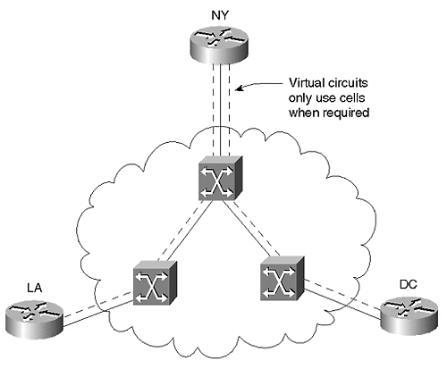
In Figure 9-2, the NY office still has a T1 to the local CO. However, this T1 line is unchannelized—it acts as a single pipe to the ATM switch sitting in the CO. The advantage of this approach is that cells are only sent when there is a need to deliver data (other than some overhead cells). In other words, if no traffic is being exchanged between the NY and LA sites, 100 percent of the bandwidth can be used to send traffic between NY and DC. Seconds later, 100 percent of the bandwidth might be available between NY and LA. Notice that, although the T1 still delivers a constant flow of 1,544,000 bps, this fixed amount of bandwidth is better utilized because there are no hard-coded multiplexing patterns that inevitably lead to unused bandwidth. The result is a significant improvement over the static multiplexing configured in Figure 9-1. In fact, many studies have shown that cell multiplexing can double the overall bandwidth utilization in a large network.

Low Latency
Latency is a measurement of the time that it takes to deliver information from the source to the destination. Latency comes from two primary sources:
- Propagation delay
- Switching delay
Propagation delay is based on the amount of time that it takes for a signal to travel over a given type of media. In most types of copper and fiber optic media, signals travel at approximately two-thirds the speed of light (in other words, about 200,000 meters per second). Because this delay is ultimately controlled by the speed of light, propagation delay cannot be eliminated or minimized (unless, of course, the two devices are moved closer together).
Switching delay results from the time it takes for data to move through some internetworking device. Two factors come into play here:
- The length of the frame—
If very large frames are in use, it takes a longer period of time for the last bit of a frame to arrive after the first bit arrives.
- The switching mechanics of the device—
Software-based routers can add several hundred microseconds of delay during the routing process, whereas hardware-based devices can make switching and routing decisions in only several microseconds.
Cells are an attempt to address both of these issues simultaneously. Because cells are small, the difference between the arrival time of the first and last bit is minimized. Because cells are of a fixed size and format, they readily allow for hardware-based optimizations.

Facilitates Multiservice Traffic
One of the most touted benefits of ATM is its capability to simultaneously support voice, video, and data traffic over the same switching infrastructure. Cells play a large part in making this possible by allowing all types of traffic to be put in a single, ubiquitous container.
Part of this multiservice benefit is derived from points already discussed. For example, one of the biggest challenges facing voice over IP is the large end-to-end latency present in most existing IP networks. The low latency of cell switching allows ATM to easily accommodate existing voice applications. In addition, the advanced multiplexing of cells allows ATM to instantly make bandwidth available to data applications when video and voice traffic is reduced (either through compression or tearing down unused circuits). Furthermore, the small size of cells prevents data logjams that can result in many other architectures when small packets clump up behind large packets (much like small cars clumping up behind trucks on the highway).

Why 53 Bytes?
As discussed in the previous section, every cell is a fixed-length container of information. After considerable debate, the networking community settled on a 53-byte cell. This 53-byte unit is composed of two parts: a 5-byte header and a 48-byte payload. However, given that networking engineers have a long history of using even powers of two, 53 bytes seems like a very strange number. As it turns out, 53 bytes was the result of an international compromise. In the late 1980s, the European carriers wanted to use ATM for voice traffic. Given the tight latency constraints required by voice, the Europeans argued that a 32-byte cell payload would be most useful. U.S. carriers, interested in using ATM for data traffic, were more interested in the efficiency that would be possible with a larger, 64-byte payload. The two groups compromised on the mid-point value, resulting in the 48-byte payload still used today. The groups then debated the merits of various header sizes. Although several sizes were proposed, the 5-byte header was ultimately chosen.

How Does an IP Packet Fit Inside a Cell?
To answer this question, this section examines the three-step process that ATM uses to transfer information:
Step 1. Slice & Dice
Step 2. Build Header
Step 3. Ship Cells
Each of these steps equates to a layer in the ATM stack shown in Figure 9-3.

Figure 9-3 Three-Layer ATM Stack
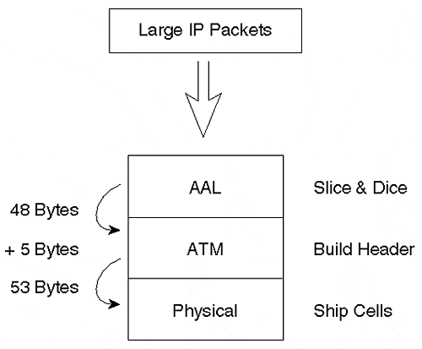
First, ATM must obviously chop up large IP packets before transmission. The technical term for this function is the ATM Adaptation Layer (AAL); however, I use the more intuitive term Slice & Dice Layer. The purpose of the Slice & Dice Layer is to act like a virtual Cuisinart\xa8 that chops up large data into small, fixed size pieces. This is frequently referred to as SAR, a term that stands for Segmentation And Reassembly, and accurately portrays this Slice & Dice function (it is also one of the two main functions performed by the AAL). Just as Cuisinarts are available with a variety of different blades, the AAL blade can Slice & Dice in a variety of ways. In fact, this is exactly how ATM accommodates voice, video, and data traffic over a common infrastructure. In other words, the ATM Adaptation Layer adapts all types of traffic into common ATM cells. However, regardless of which Slice & Dice blade is in use, the AAL is guaranteed to pass a fixed-length, 48-byte payload down to the next layer, the ATM layer.
The middle layer in the ATM stack, the ATM layer, receives the 48-byte slices created by the AAL. Note the potential for confusion here: all three layers form the ATM stack, but the middle layer represents the ATM layer of the ATM stack. This layer builds the 5-byte ATM cell header, the heart of the entire ATM process. The primary function of this header is to identify the remote ATM device that should receive each cell. After this layer has completed its work, the cell is guaranteed to be 53 bytes in length.
Note
Technically, there is a small exception to the statement that the ATM Layer always passes 53-byte cells to the physical layer. In some cases, the physical layer is used to calculate the cell header's CRC, requiring only 52-byte transfers. In practice, this minor detail can be ignored.

At this point, the cells are ready to leave the device in a physical layer protocol. This physical layer acts like a shipping department for cells. The vast majority of campus ATM networks use Synchronous Optical Network (SONET) as a physical layer transport. SONET was developed as a high-speed alternative to the T1s and E1s discussed earlier in this chapter.
Note
SONET is very similar to T1s in that it is a framed, physical layer transport mechanism that repeats 8,000 times per second and is used for multiplexing across trunk links. On the other hand, they are very different in that SONET operates at much higher bit rates than T1s while also maintaining much tighter timing (synchronization) parameters. SONET was devised to provide efficient multiplexing of T1, T3, E1, and E3 traffic.

Think of a SONET frame as a large, 810-byte moving van that leaves the shipping dock every 1/8000th of a second (810 bytes is the smallest/slowest version of SONET; higher speeds use an even larger frame!). The ATM Layer is free to pack as many cells as it can fit into each of these 810-byte moving vans. On a slow day, many of the moving vans might be almost empty. However, on a busy day, most of the vans are full or nearly full.
One of the most significant advantages of ATM is that it doesn't require any particular type of physical layer. That is, it is media independent. Originally, ATM was designed to run only over SONET. However, the ATM Forum wisely recognized that this would severely limit ATM's potential for growth and acceptance, and developed standards for many different types and speeds of physical layers. In fact, the Physical Layer Working Group of the ATM Forum has been its most prolific group. Currently, ATM runs over just about any media this side of barbed wire.

Why Is It Asynchronous Transfer Mode?
The term Asynchronous Transfer Mode has created significant confusion. Many ask, "What's asynchronous about it? Is this a throwback to using start and stop bits like my modem?"
ATM is asynchronous in the sense that cells are generated asynchronously on an as-needed basis. If two ATM devices have a three-second quiet period during an extended file transfer, ATM does not need to send any cells during this three-second interval. This unused bandwidth is instantly available to any other devices sharing that link. In other words, it is the asynchronous nature of ATM that delivers the advanced statistical multiplexing capabilities discussed earlier.
This confusion is further complicated by the common use of SONET as a physical layer for ATM. Because Synchronous Optical Network is obviously synchronous, how can ATM be asynchronous if SONET is in use? To answer this question, apply the logic of the previous paragraph: ATM is only referring to the generation of cells as being asynchronous. How cells get shipped from point A to point B is a different matter. In the case of SONET, the shipment from point A to point B is most definitely synchronous in that SONET moving vans (frames) leave the shipping dock (the ATM device) at exactly 1/8000th of a second intervals. However, filling these moving vans is done on an as-needed or asynchronous basis. Again, this is exactly what gives ATM its amazing statistical multiplexing capabilities. All of the empty space in the moving van is instantly available to other devices and users in the network.

What Is the Difference Between ATM and SONET?
As discussed in the previous sections, ATM and SONET are closely related technologies. In fact, they were originally conceived to always be used together in a global architecture called BISDN (Broadband Integrated Digital Services Network). However, they have been developed (and often implemented) as two different technologies. ATM is a cloud technology that deals with the high-speed generation and transportation of fixed-size units of information called cells. SONET, on the other hand, is a point-to-point technology that deals with the high-speed transportation of anything, including ATM cells.
In other words, referring back to the three-layer model, ATM makes the cells and SONET ships the cells.
Tip
ATM and SONET are two different concepts. ATM deals with cells and SONET is simply one of the many physical layers available for moving ATM cells from point to point.

ATM Is Connection Oriented
ATM is always connection oriented. Before any data can be exchanged, the network must negotiate a connection between two endpoints. ATM supports two types of connections:
- Permanent virtual circuits (PVCs)
- Switched virtual circuits (SVCs)
PVCs act like virtual leased lines in that the circuits are always active. PVCs are manually built based on human intervention (either via a command-line interface [CLI] or some action at a management console).
SVCs are "dialup" ATM connections. Think of them as ATM phone calls. When two devices require connectivity via a SVC, one device signals the ATM network to build this temporary circuit. When the connection is no longer required, one of the devices can destroy the SVC via signaling.
ATM always requires that one of these two types of circuits be built. At the cell layer, it is not possible for ATM to provide a connectionless environment like Ethernet. However, it is entirely possible for this connection-oriented cell layer to emulate a connectionless environment by providing a connectionless service at some higher layer. The most common example of such a connectionless service is LANE, the very subject of this chapter.
ATM supports two configurations for virtual circuits (VCs):
Step 1. Point-to-point Virtual Circuits
Step 2. Point-to-multipoint Virtual Circuits
Figure 9-4 illustrates both types of circuits.

Figure 9-4 Point-to-Point and Point-to-Multipoint Vcs
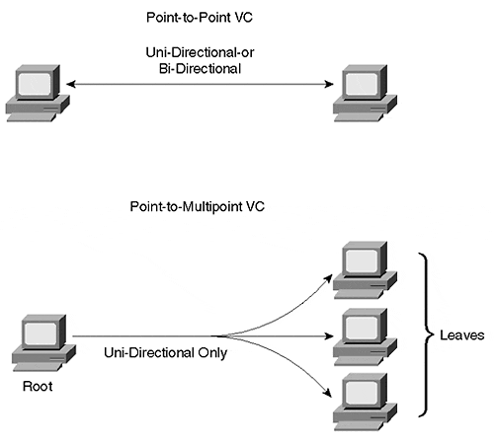
Point-to-point virtual circuits behave exactly as the name suggests: one device can be located at each end of the circuit. This type of virtual circuit is also very common in technologies such as Frame Relay. These circuits support bi-directional communication—that is, both end points are free to transmit cells.
Point-to-multipoint virtual circuits allow a single root node to send cells to multiple leaf nodes. Point-to-multipoint circuits are very efficient for this sort of one-to-many communication because it allows the root to generate a given message only once. It then becomes the duty of the ATM switches to pass a copy of the cells that comprise this message to all leaf nodes. Because of their unidirectional nature, point-to-multipoint circuits only allow the root to transmit. If the leaf nodes need to transmit, they need to build their own virtual circuits.
Tip
Do not confuse the root of a point-to-multipoint ATM VC with the Spanning Tree Root Bridge and Root Port concepts discussed in Chapter 6, "Understanding Spanning Tree." They are completely unrelated concepts.

ATM Addressing
As with all other cloud topologies, ATM needs some method to identify the intended destination for each unit of information (cell) that gets sent. Unlike most other topologies, ATM actually uses two types of addresses to accomplish this task: Virtual Path Indicator/Virtual Channel Indicator (VPI/VCI) addresses and Network Services Access Point (NSAP) addresses, both of which are discussed in greater detail in the sections that follow.

VPI/VCI Addresses
VPI/VCI, the first type of address used by ATM, is placed in the 5-byte header of every cell. This address actually consists of two parts: the Virtual Path Indicator (VPI) and the Virtual Channel Indicator (VCI). They are typically written with a slash separating the VPI and the VCI values—for example, 0/100. The distinction between VPI and VCI is not important to a discussion of LANE. Just remember that together these two values are used by an ATM edge device (such as a router) to indicate to ATM switches which virtual circuit a cell should follow. For example, Figure 9-5 adds VPI/VCI detail to the network illustrated in Figure 9-2 earlier.

Figure 9-5 VPI/VCI Usage in an ATM Network
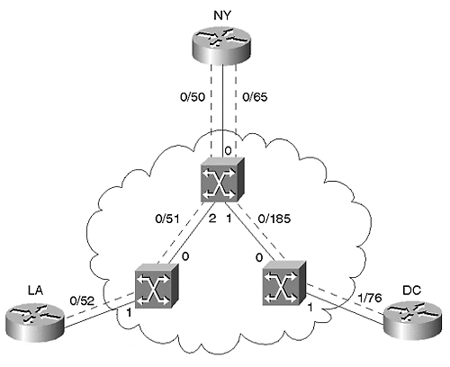
The NY router uses a single physical link connected to Port 0 on the NY ATM switch carrying both virtual circuits. How, then, does the ATM switch know where to send each cell? It simply makes decisions based on VPI/VCI values placed in ATM cell headers by the router. If the NY router (the ATM edge device) places the VPI/VCI value 0/50 in the cell header, the ATM switch uses a preprogrammed table indicating that the cell should be forwarded out Port 2, sending it to LA. Also, note that this table needs to instruct the switch to convert the VPI/VCI value to 0/51 as the cells leave the Port 1 interface (only the VCI is changed). The ATM switch in LA has a similar table indicating that the cell should be switched out Port 1 with a VPI/VCI value of 0/52. However, if the NY router originates a cell with the VPI/VCI value 0/65, the NY ATM switch forwards the cell to DC. The ATM switching table in the NY ATM switch would contain the entries listed in Table 9-1.

Table 9-1. Switching Table in NY ATM Switch
input |  |  | output
Port | VPI | VCI | Port | VPI | VCI
0 | 0 | 50 | 2 | 0 | 51
0 | 0 | 65 | 1 | 0 | 185
1 | 0 | 185 | 0 | 0 | 65
2 | 0 | 51 | 0 | 0 | 50
Notice the previous paragraph mentions that the ATM switch had been preprogrammed with this switching table. How this preprogramming happens depends on whether the virtual circuit is a PVC or an SVC. In the case of a PVC, the switching table is programmed through human intervention (for example, through a command-line interface). However, with SVCs, the table is built dynamically at the time the call is established.

NSAPs
The previous section mentioned that SVCs build the ATM switching tables dynamically. This requires a two-step process:
Step 1. The ATM switch must select a VPI/VCI value for the SVC.
Step 2. The ATM switch must determine where the destination of the call is located.
Step 1 is a simple matter of having the ATM switch look in the table to find a value currently not in use on that port (in other words, the same VPI/VCI can be in use on every port of the same switch; it just cannot be used twice on the same port).
To understand Step 2, consider the following example. If the NY router places an SVC call to DC, how does the New York ATM switch know that DC is reachable out Port 1, not Port 2? The details of this process involve a complex protocol called Private Network-Network Interface (PNNI) that is briefly discussed later in this chapter. For now, just remember that the NY switch utilizes an NSAP address to determine the intended destination. NSAP addresses function very much like regular telephone numbers. Just as every telephone on the edge of a phone network gets a unique phone number, every device on an ATM network gets a unique NSAP address. Just as you must dial a phone number to call your friend named Joe, an ATM router must signal an NSAP address to call a router named DC. Just as you can look at a phone number to determine the city and state in which the phone is located, an NSAP tells you where the router is located.
However, there is one important difference between traditional phone numbers and NSAP addresses: the length. NSAPs are fixed at 20 bytes in length. When written in their standard hexadecimal format, these addresses are 40 characters long! Try typing in a long list of NSAP addresses and you quickly learn why an ATM friend of mine refers to NSAPs as Nasty SAPs! You also learn two other lessons: the value of cut-and-paste and that even people who understand ATM can have friends (there's hope after all!).
NSAP addresses consist of three sections:
- A 13-byte prefix.This is a value that uniquely identifies every ATM switch in the network. Logically, it functions very much like the area code and exchange of a U.S. phone number (for example, the 703-242 of 703-242-1111 identifies a telephone switch in Vienna, Virginia). Cisco's campus ATM switches are preconfigured with 47.0091.8100.0000, followed by a unique MAC address that gets assigned to every switch. For example, a switch that contains the MAC address 0010.2962.E801 uses a prefix of 47.0091.8100.0000.0010.2962.E801. No other ATM switch in your network can use this prefix.
- A 6-byte End System Identifier (ESI).This value identifies every device connected to an ATM switch. A MAC address is typically used (but not required) for this value. Logically, it functions very much like the last four digits of a U.S. phone number (for example, the 1111 of 703-242-1111 identifies a particular phone attached to the Vienna, Virginia telephone switch).
- A 1-byte selector byte.This value identifies a particular software process running in an ATM-attached device. It functions very much like an extension number associated with a telephone number (for example, 222 in 703-242-1111 x222). Cisco devices typically use a subinterface number for the selector byte.
Figure 9-6 illustrates the ATM NSAP format.

Figure 9-6 ATM NSAP Format
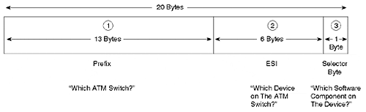
An actual NSAP appears as follows:
47.009.8100.0000.0060.8372.56A1 . 0000.0c33.BFC1 . A1
Extra spaces have been inserted to clearly delineate the three sections. The pattern of dots above is optional. If you are a particularly adept typist, feel free to completely omit the dots. However, most people find a pattern such as the one above to be a very useful typing aid.

Using NSAP and VPI/VCI Addresses Together
In short, the purpose of the two types of ATM addresses can be summarized as follows:
- NSAP addresses are used to build SVCs.
- VPI/VCIs are used after the circuit (SVC or PVC) has already been built to deliver cells across the circuit.
Tip
ATM NSAP addresses are only used to build an SVC. After the SVC is built, only VPI/VCI addresses are used.

Figure 9-7 illustrates the relationship between NSAP and VPI/VCI addresses. The NSAPs represent the endpoints whereas VPI/VCIs are used to address cells as they cross each link.

Figure 9-7 Using NSAP Addresses to Build VPI/VCI Values for SVCs
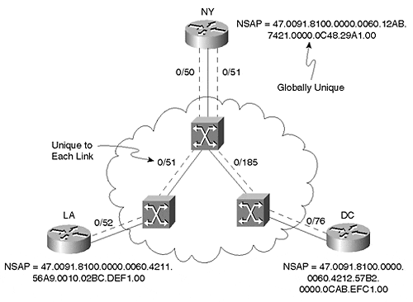
Table 9-2 documents the characteristics of NSAP and VPI/VCI addresses for easy comparison.

Table 9-2. NSAP Versus VPI/VCI Address Characteristics
NSAP Addresses | VPI/VCI Addresses
40 hex characters (20 bytes) in length | 24 to 28 bits in length (depending on what type of link the cell is traversing)
Globally significant (that is, globally unique) | Locally significant (that is, only need to be unique to a single link)
Physically reside in the signaling messages used to build SVCs | Physically reside in the 5-byte header of every ATM cell
Not used for PVCs | Used for PVCs and SVCs

ATM Device Types
ATM devices can be divided into one of two broad categories, each of which is covered in greater detail in the sections that follow:
- ATM edge devices
- ATM switches

ATM Edge Devices
ATM edge devices include equipment such as workstations, servers, PCs, routers, and switches with ATM interface cards (for example, a Catalyst 5000 containing a LANE module). These devices act as the termination points for ATM PVCs and SVCs. In the case of routers and switches, edge devices must also convert from frame-based media such as Ethernet to ATM cells.

ATM Switches
ATM switches only handle ATM cells. Cisco's campus switches include the LightStream LS1010 and 8500 MSR platforms (Cisco also sells several carrier-class switches developed as a result of their Stratacom acquisition). ATM switches are the devices that contain the ATM switching tables referenced earlier. They also contain advanced software features (such as PNNI) to allow calls to be established and high-speed switching fabrics to shuttle cells between ports. Except for certain overhead circuits, ATM switches generally do not act as the termination point of PVCs and SVCs. Rather, they act as the intermediary junction points that exist for the circuits connected between ATM edge devices.
Figure 9-8 illustrates the difference between edge devices and ATM switches.

Figure 9-8 Catalyst ATM Edge Devices Convert Frames to Cells, Whereas ATM Switches Handle Only Cells
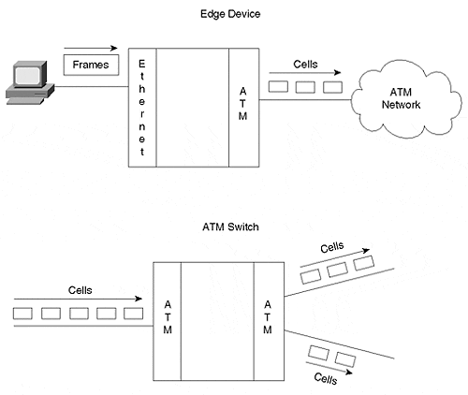
Tip
Remember the difference between ATM edge devices and ATM switches. ATM edge devices sit at the edge of the network, but ATM switches actually are the ATM network.

Products such as the Catalyst 5500 and 8500 actually support multiple functions in the same chassis. The 5500 supports LS1010 ATM switching in its bottom five slots while simultaneously accommodating one to seven LANE modules in the remaining slots. However, it is often easiest to think of these as two separate boxes that happen to share the same chassis and power supplies. The bottom five slots (slots 9–13) accommodate ATM switch modules while slots 2–12 accommodate ATM edge device modules (note that slots 9–12 can support either service).
Tip
Cisco sells several other devices that integrate ATM and frame technologies in a single platform in a variety of different ways. These include the Catalyst 5500 Fabric Integration Module (FIM), the Catalyst 8500 MSR, and the ATM Router Module (ARM). See Cisco's Product Catalog for more information on these devices.

ATM Overhead Protocols
Although ATM theory can be extremely complex, the good news is that it can be amazingly easily to implement in most networks. This plug-and-play nature is due in large part to two automation protocols: Integrated Local Management Interface (ILMI) and Private Network-Network Interface (PNNI).

ILMI
Integrated Local Management Interface (ILMI) is a protocol created by the ATM Forum to handle various automation responsibilities. Initially called the Interim Local Management Interface, ILMI utilizes SNMP to allow ATM devices to "automagically" learn the configuration of neighboring ATM devices. The most common use of ILMI is a process generally referred to as address registration. Recall that NSAP addresses consist of three parts: the switch's prefix and the edge device's ESI and selector byte. How do the two devices learn about each other's addresses? This is where ILMI comes in. Address registration allows the edge device to learn the prefix from the switch and the switch to learn the ESI from the edge device (because the selector byte is locally significant, the switch doesn't need to acquire this value).

PNNI
Private Network-Network Interface (PNNI) is a protocol that allows switches to dynamically establish SVCs between edge devices. However, edge devices do not participate in PNNI—it is a switch-to-switch protocol (as the Network-Network Interface portion of the name suggests). Network-Network Interface (NNI) protocols consist of two primary functions:
- Signaling
- Routing
Signaling allows devices to issue requests that create and destroy ATM SVCs (because PVCs are manually created, they do not require signaling for setup and tear down).
Routing is the process that ATM switches use to locate the destination the NSAP addresses specified in signaling requests. Note that this is very different from IP-based routing. IP routing is a connectionless process that is performed for each and every IP datagram (although various caching and optimization techniques do exist). ATM routing is only performed at the time of call setup.After the call has been established, all of the traffic associated with that SVC utilizes the VPI/VCI cell-switching table. Note that this distinction allows ATM to simultaneously fulfill the conflicting goals of flexibility and performance. The unwieldy NSAP addresses provide flexible call setup schemes, and the low-overhead VPI/VCI values provide high-throughput and low-latency cell switching.
Tip
Do not confuse ATM routing and IP routing. ATM routing is only performed during call setup when an ATM SVC is being built. On the other hand, IP routing is a process that is performed on each and every IP packet.

When to Use ATM
Although ATM has enjoyed considerable success within the marketplace, the debate continues: which is better—ATM or competing technologies such as Gigabit Ethernet in the campus and Packet Over SONET in the WAN? Well, like most other issues in the internetworking field, the answer is "it depends."
Specifically, ATM has distinct advantages in the following areas:
- Full support for timing-critical applications
- Full support for Quality of Service (QoS)
- Communication over long geographic distances
- Theoretically capable of almost unlimited throughput
Die-hard geeks often refer to timing-critical applications as isochronous applications. Isochronous is a fancy term used to describe applications such as voice and video that have very tight timing requirements. Stated differently, the chronous (greek word for timing) must be isos (Greek word for equal). Traditional techniques used to encode voice and video such as PCM for voice and H.320 for video are generally isochronous and can benefit greatly from ATM's circuit emulation capabilities. If your voice and video traffic is isochronous and you want to use a single network infrastructure for voice, video, and data, ATM is about your only choice other than bandwidth-inefficient TDM circuits. However, note that there is a growing movement away from isochronous traffic. For example, voice over IP and H.323 video are non-isochronous mechanisms that can run over frame-based media such as Ethernet.
At the time of writing, ATM is the only data technology in common use that reliably supports Quality of Service (QoS). This allows bandwidth and switch processing to be reserved and guaranteed for critical applications like voice and video. Although Ethernet, IP, and other data communication technologies are beginning to offer QoS, these efforts are still in their infancy. Many ATM users argue that Ethernet and IP-based forms of QoS are be better termed Class of Service (CoS) because the reservation and isolation mechanisms are not as strong as can be found in ATM (ATM was built from the ground up to support QoS).
For many network designers, one of the most compelling advantages of ATM is freedom from distance constraints. Even without repeaters, ATM supports much longer distances than any form of Ethernet. With repeaters (or additional switches), ATM can cover any distance. For example, with ATM it is very simple and cost-effective to purchase dark fiber between two sites that are up to 40 kilometers apart (much longer distances are possible) and connect the fiber to OC-12 long-reach ports on LS1010 ATM switches (no repeaters are required). By using repeaters and additional switches, ATM can easily accommodate networks of global scale. However, on the other hand, a number of vendors have introduced forms of Gigabit Ethernet ports capable of reaching 100 kilometers without a repeater such as Cisco's ZX GBIC. Although this does not allow transcontinental Ethernet connections, it can accommodate many campus requirements.
ATM has historically been considered one of the fastest (if not the fastest) networking technologies available. However, this point has recently become the subject of considerable debate. The introduction of hardware-based, Gigabit-speed routers (a.k.a. Layer 3 switches) has nullified the view that routers are slow, causing many to argue that modern routers can be just as fast as ATM switches. On the other hand, ATM proponents argue that ATM's low-overhead switching mechanisms will always allow for higher bandwidth than Layer 3 switches can support. Only time will tell.
In short, the decision to use ATM is no longer a clear-cut choice. Each organization must carefully evaluate its current requirements and plans for future growth. For additional guidelines on when to use ATM and when not to use ATM, see Chapter 15, "Campus Design Implementation."

LANE: Theory of Operation
Now that the chapter has built a common foundation of ATM knowledge, the following sections dive into the specifics of LAN Emulation. Before beginning, let me reiterate that the goal is not to clobber you with every subtle nuance of LANE (although it will probably feel like that in ten pages). For example, the LANE specifications contain many optional features—rather than trying to highlight every option, the material focuses on the real-world applications and common practices of LANE.

VLAN Versus ELAN
Many documents treat the terms Virtual LAN (VLAN) and Emulated LAN (ELAN) as synonyms; however, although related, they are arguably different concepts. As discussed in Chapter 5, "VLANs," the term VLAN is used to describe a broadcast domain, in other words, an IP subnet. In a similar fashion, ELANs also act as broadcast domains, and each ELAN has a unique IP subnet address. However, an ELAN is also a specific type of a VLAN: a LAN emulated over ATM. Whereas VLANs can exist over any medium, ELANs only exist in an ATM environment. Whereas all ELANs are VLANs, not all VLANs are ELANs.

The LANE Fake Out: Simulating LANs
As it creates emulated LANs, LANE functions as a sophisticated fake out. Specifically, it fools higher-layer protocols into believing that the network infrastructure consists of Ethernet or Token Ring links when, in fact, the network is composed of an ATM cloud. In this chapter, we focus exclusively on Ethernet-style LANE.
To fool higher-layer protocols into believing that Ethernet is in use, LANE must simulate two important aspects of Ethernet not found in normal ATM networks:
- MAC addresses—
As discussed in Chapter 1, "Desktop Technologies," Ethernet devices use 6-byte MAC addresses. However, as discussed earlier in this chapter, ATM uses NSAP addresses to create new ATM SVC connections. Some means to convert between these two addressing schemes must exist.
- Broadcasting—
Given the connection-oriented nature of ATM discussed earlier, broadcasting and multicasting become non-trivial exercises in an ATM environment. However, because higher-layer protocols have always made extensive use of Ethernet's broadcast capabilities, some broadcast mechanism must be devised.
Note
Recall that LANE is a technique for bridging traffic over an ATM network. As a bridging technology, LANE therefore uses the Spanning-Tree Protocol discussed in Chapters 6 and 7. Note that this also implies a lower limit on failover performance: features such as SSRP, discussed later, might fail over in 10–15 seconds, however, Spanning Tree prevents traffic from flowing for approximately 30 seconds by default.
Because of this delay, some ATM vendors disable Spanning Tree by default. Because of the risks associated with doing this (loops can easily be formed in the Ethernet portion of the network), Cisco enables Spanning Tree over LANE by default.

Let's Go to The LANE Bar
This section uses the analogy of a play or skit called "The LANE Bar." Not only does this provide an opportunity for some comic relief in the middle of a long and technically challenging chapter, it provides a strong parallel and memory aid for how LANE functions.
The director of this play is none other than the ATM Forum, world-renowned producers of such Broadway hits as "UNI 3.1," "PNNI," and "Circuit Emulation Service." The play is about deception and deceit—about a group of thugs who fake out a bunch of innocent Ethernet hosts one night. The director has chosen to include four characters.

The Four Characters (Components) of LANE
LANE uses four characters (components) to create the fake out discussed in the previous section. Most vendors implement these components in software that runs on edge devices (although hardware-assisted, hardware-based, and switch-based components are possible). In total, LANE uses one client character and three server characters. The characters (described in the ensuing sections) are as follows:
- LAN Emulation Clients (LECs)
- LAN Emulation Configuration Server (LECS)
- LAN Emulation Server (LES)
- Broadcast and Unknown Server (BUS)

Starring Role: LEC
LAN Emulation Clients (LECs, note the lowercase "s") are edge devices where the fake out actually occurs. In the case of Catalyst LECs, the Catalyst LANE module runs software that fools Ethernet-attached hosts into believing that the ATM backbone is actually Ethernet. LECs are often referred to as Clients and have a starring role in the play. There are two types of LECs: Normal LECs and Proxy LECs.
Normal LECs are everyday devices that happen to contain an ATM interface. For example, take a Windows NT server and place an ATM NIC in one of its expansion slots. Configure it to run LEC software, and the PC can now communicate directly to other devices over the ATM backbone.
Proxy LECs (PLECs) are a slightly different animal. Proxy LECs also directly connect to the ATM backbone and run some sort of LEC software, however, they usually generate very little traffic by themselves. For example, take a Catalyst 5000 that contains a LANE uplink module. Left alone, the Catalyst 5000 generates minute amounts of overhead traffic such as Spanning-Tree Protocol, VLAN Trunking Protocol (VTP), and so forth. The vast majority of traffic that the Catalyst needs to send is on behalf of the Ethernet-attached devices connected to 10/100 Ethernet ports (some B-grade supporting actors sitting just off-stage). However, these Ethernet-attached PCs, workstations, and servers cannot become LECs—after all, they aren't connected to the ATM cloud! It is the Catalyst LANE module that acts as a proxy or agent on behalf of these devices.
LANE Clients serve as the front lines of the fake out; however, left to their own capabilities, LECs would be hopeless. To complete the fake out, our stars (LECs) require the services of three supporting actors (server components). In fact, these three servers allow a Client to join an Emulated LAN.

Supporting Actor: LECS
To begin this joining process, Clients require two things: security and hospitality.
These two functions are provided by a character (component) referred to as the LAN Emulation Configuration Server, or LECS (note the uppercase "S"). This character has been cast as a large, burly fellow with a huge neck, bald head, and a large tattoo on his left arm. He is affectionately referred to as The Bouncer. This character stands at the front door of the nightclub to provide security ("Hey, I need to see your ID!") and hospitality ("The bartender is located over there.") to thirsty Clients.
Tip
The acronyms used by LANE can lead to considerable confusion. This is especially true when using the terms LECs (more than one LANE Client) and LECS (a single LANE Configuration Server). You might want to always pronounce LEC as "Client" and LECS as "Config Server" to avoid this confusion.

Supporting Actor: LES
No barroom would be complete without a Bartender. This important character runs the show in each bar (ELAN). The other characters typically refer to the Bartender by his nickname, LES. Because the directors see this as a high-class bar, they have asked LES to carefully keep track of every Client sitting in the bar (joined the ELAN). To not fail at this task, LES keeps of a list of every Client's name (MAC address) on a clipboard. In addition, LES makes a note of the table number (NSAP address) where every Client is sitting. Therefore, Client actors can ask questions like, "Where's Billy Bob (MAC address 0000.0C12.3456) sitting?" LES can then easily give an answer: "He's at table 219 (NSAP address 47.0091.8100.0000.0060.8372.56A1.0000.0c33.BFC1.A1)!"

Supporting Actor: BUS
The owner of the bar has noticed that the situation sometimes gets a little out of hand in the bar. Get a room full of Clients together and you never know what will happen! One of the problems, especially on Friday nights, is that Clients tend to jump on the tables and start dancing around to attract attention from all other Clients in the bar. Because this has proven to be hard on both the tables and the Clients, our director has requested a special supporting actor called the Broadcast and Unknown Server, or BUS for short. This sly character has earned the title of The Barroom Gossip—you tell him one thing and he's guaranteed to tell everyone else in the bar!

The Setting
Our play is set in the exciting community of Geektown. In building the set, the director has spared no expense. On stage, the workers have carefully built an entire nightclub. This is a single, large brick building (ATM cloud) that contains two separate barrooms (ELANs). On the right, we have The Funky Bit-Pipe, a popular local discotheque. On the left, The Dusty Switch, an always-crowded country-western bar.

Plot Synopsis
Act I is where the main drama occurs and consists of five scenes:
- Scene 1—Configuration Direct—
Client Contacts the Bouncer (LECS): The play begins with a lone Client standing outside the barroom. The Client is clad in a pair of shiny new cowboy boots, a wide-brimmed Stetson hat, and a Garth Brooks look-alike shirt. Before the Client can enter the bar and quench his thirst, he must locate the Bouncer (LECS) standing at the front door to the nightclub. The Bouncer performs a quick security check and, noticing the Client's cowboy attire, points the Client in the direction of the Bartender (LES) for the Dusty Switch barroom (ELAN).
- Scene 2—Control Direct—
Client Contacts the Bartender (LES): As soon as the Client enters the bar, it must approach the Bartender. Then, the Bartender makes a note of the Client's name (MAC address) and table number (NSAP address). Notice that this solves the first requirement of the LANE fake out by providing MAC address to NSAP address mapping.
- Scene 3—Control Distribute—
Bartender (LES) Contacts the Client: As every Client enters the barroom, the Bartender adds it as a leaf node to a special fan-out point-to-multipoint VC. After the new Client contacts the Bartender, the Bartender must add this Client as well. This fan-out circuit allows the Bartender to easily send a single frame that gets distributed to all Clients in the ELAN by the ATM switches. "Happy Hour!" and "Last Call!" are commonly heard messages.
- Scene 4—Multicast Send—
Client Contacts the Gossip (BUS): The Client then acquires the location of the Gossip (BUS) from the Bartender (LES). Next, the Client uses this address to build a connection to the Gossip, allowing the Client to easily send broadcasts and multicasts to everyone in the bar. Notice that this solves the second requirement of the fake out: the capability to send broadcast and multicast frames.
- Scene 5—
Multicast Forward—The Gossip (BUS) Contacts the Client: Just as the Bartender has special fan-out point-to-multipoint circuits that can be used to efficiently reach every Client in the barroom, The Gossip maintains a similar circuit. This allows the Gossip to quickly distribute all of the information he collects.
After the five scenes of Act I are complete, the Client has joined the ELAN, Act II. Notice that Acts I and II only consider the action in the Dusty Switch ELAN. While the cowboys are having fun in their ELAN, another group of Clients is dancing the night away in the discotheque ELAN. Although both barrooms share the services of the Bouncer, each bar requires its own Bartender and Gossip.

Five-Step LANE Initialization Sequence
As introduced in the previous section, the four LANE characters have to do some fancy footwork before they are allowed to communicate via LANE. This section discusses in detail each of the five scenes used to describe the complete process. Now that you are awake (and hopefully have a smile on your face), the text begins to transition away from The LANE Bar analogy (for example, Scenes 1–5 are now referred to as Steps 1–5). However, because it has proven to be a useful memory aid, the text continues to refer to the analogy with parenthetical comments.

Step 1: Configuration Direct—Client Contacts the LECS
As the first step in the joining process, the Client must locate the LECS (Bouncer). Clients can use four techniques to locate the Configuration Server:
- A manually configured NSAP address
- ILMI
- Well-known NSAP (47.0079…)
- Well-known VPI/VCI (0/17)
In reality, locating the Bouncer consists of building an ATM virtual circuit to the LECS. The first three options in the preceding list all make use of SVCs, and the last option utilizes a PVC.
The manually configured NSAP address option for LECS discovery uses the lane configatm-address command to hard-code the NSAP address of the LECS on every Client. Although this approach does provide for technical simplicity, it can lead to administrative headaches.
The ILMI approach uses the capabilities of ILMI to automate the distribution of the LECS' NSAP. This still requires the NSAP to be manually configured on every ATM switch, but because most networks have far fewer ATM switches than Clients, this can result in significantly less configuration effort. Cisco recommends this approach because it is both simple and effective (it also works well with the Simple Server Redundancy Protocol [SSRP] discussed later in this chapter).
The well-known NSAP technique is similar to dialing the police in the United States: regardless of where you are, just dial 911 and the phone system connects you to the nearest police station. In the case of LANE, dialing the well-known NSAP connects you to the nearest LECS. Although the full address is 47.007900000000000000000000.00A03E000001.00 (00A03E is the Organizational Unique Identifier [OUI] assigned by the ATM Forum), any time you see an address that begins with 47.0079 you can be fairly confident that this is an attempt to contact the LECS via the well-known NSAP. You might also run into another version of this address that begins with a C5 in place of a 47 (this uses an ATM feature called anycasting).
Note
Anycast addresses are special ATM NSAPs that allow multiple devices to advertise a single service. As clients request connections to these addresses, ATM switches automatically connect them to the nearest available device providing that service. Not only can this optimize traffic flows, it can provide an automatic form of redundancy (if the nearby server goes away, the client simply is sent to a more distant device when it tries to reconnect).

Under the well-known VPI/VCI approach, Clients always use 0/17 to communicate with the LECS. Because this method doesn't lend itself well to failure recovery, the well-known VPI/VCI technique is rarely used (it's also not included in the second version of the LANE specification).
Assuming that the LEC has acquired the Configuration Server's NSAP via ILMI, the Client then places an ATM phone call (SVC) to the LECS. This SVC is referred to as the Configuration Direct (it is a direct connection to the Configuration Server). After the Configuration Direct has been established, the Client tells the Configuration Server its NSAP address and the desired ELAN (barroom). The LECS then lives up to its title of the Bouncer by providing the Client with the following:
- Security—
Optionally checks the Client's NSAP address as a security measure
- Hospitality—
Tells the Client how to reach the bartender (LES) of the desired barroom (ELAN)
Also, if the Client doesn't request a specific ELAN, the Bouncer can optionally provide a default ELAN.
Figure 9-9 illustrates the Configuration Direct VC.

Figure 9-9 Step 1: The Client Contacts the Configuration Server to Get the NSAP of the LES
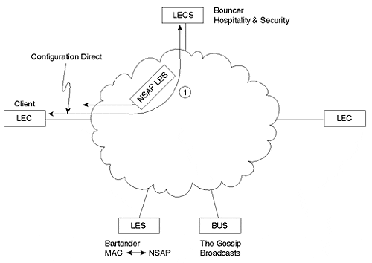
Assuming that the Client meets the security requirements and the requested ELAN exists, the LECS provide the NSAP of the LES to the Client. At this point, the Configuration Direct can optionally be torn down to conserve virtual circuits on the ATM switch (Cisco devices take advantage of this option).

Step 2: Control Direct—Client Contacts the LES
After the Client has acquired the LES's NSAP address, it requests an SVC to this location. This SVC is known as a Control Direct, the direct connection to the device that controls the ELAN, the LES. The Client sends his MAC address (Name) and NSAP address (barroom table he is sitting at) to the LES (bartender). The LES then makes a note of these entries in its database. Figure 9-10 shows the Control Direct VC.

Figure 9-10 Step 2: The Client Contacts the LES and Registers Its MAC and NSAP Addresses
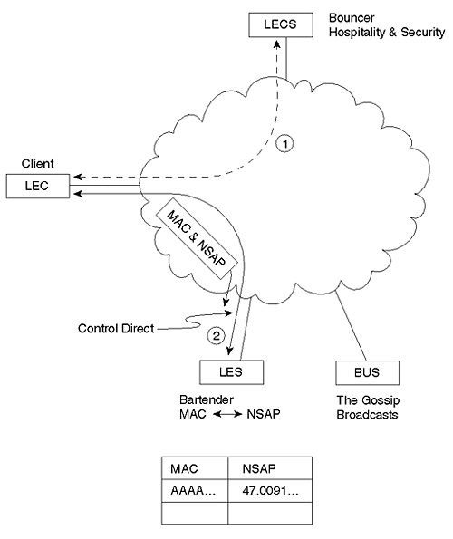

Step 3: Control Distribute—LES Contacts the Client
Using the NSAP address registered over the Control Direct, the LES needs to call back the Client. However, this is not a normal, point-to-point phone call. Prior to this Client's attempt to join, the LES already owned a point-to-multipoint VC to every Client in the ELAN. In other words, every existing Client is a leaf node and the LES is the root node of this unidirectional circuit. The LES then issues an ADD_PARTY message to add the new Client as a leaf node. Figure 9-11 illustrates the resulting Control Distribute VC.

Figure 9-11 Step 3: The LES Adds the Client to the Already Existing Control Distribute Point-to-Multipoint Circuit
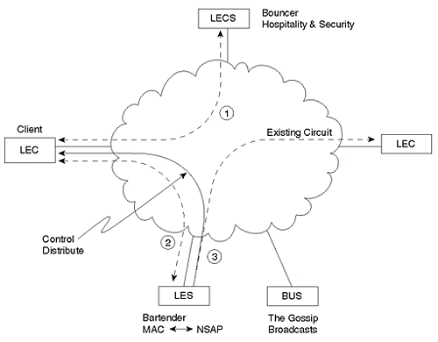

Step 4: Multicast Send—The Client Contacts the BUS
As might be expected, the Client ultimately uses the Control Direct VC established in Step 3 to map MAC addresses into NSAP addresses. The name of the message used to perform this mapping process is an LE_ARP message. An LE_ARP_REQUEST allows a Client to locate the NSAP address associated with another Client's MAC address. LE_ARP_REPLIES are used by the LES to answer LE_ARP_REQUESTS.
Notice that the Client is still in the process of joining and LE_ARPs cannot be used to contact other Clients until the join process is complete. However, the Client LE_ARPs to locate the BUS (the Gossip). The Client issues an LE_ARP_REQUEST for the MAC address FFFF.FFFF.FFFF to resolve the NSAP of the BUS. In other words, the Client LE_ARPs for the broadcast MAC address to locate the device that handles broadcast traffic: the BUS. After the Client LE_ARPs for FFFF.FFFF.FFFF, the LES responds with the NSAP address of the BUS. The Client uses this information to build a Multicast Send VC to the BUS as shown in Figure 9-12.

Figure 9-12 Step 4: The Client Builds the Multicast Send to the BUS
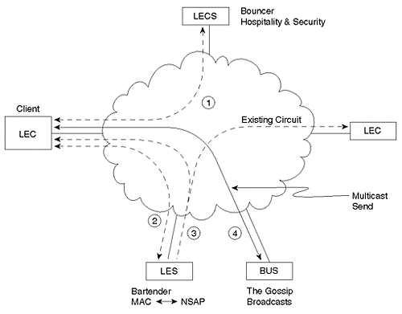

Step 5: Multicast Forward—The BUS Contacts the Client
As with the LES, the BUS maintains a point-to-multipoint connection to every Client in the ELAN. After the BUS learns of the new Client via the Multicast Send, it calls back the Client by issuing an ADD_PARTY message for that device. This VC is referred to as the Multicast Forward.
This point-to-multipoint VC provides a fairly efficient method for Clients to issue broadcast and multicast traffic to each other. After Clients forward traffic to the BUS, it sends the traffic out the Multicast Forward to all devices in the ELAN. Figure 9-13 illustrates the Multicast Forward.

Figure 9-13 Step 5: The BUS Adds the Client to the Multicast Forward
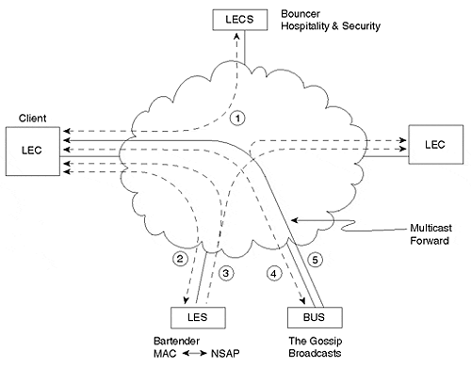

The Client Has Joined!
After the five overhead connections have been built, the Client has officially joined the ELAN. At this point, the Client is free to issue LE_ARP_REQUESTs for other Clients in the ELAN. The resulting connections, Data Direct VCs, are the primary communication path between LANE Clients. Figure 9-14 illustrates a Data Direct circuit.

Figure 9-14 Data Direct VCs are created by Clients after they have joined the ELAN
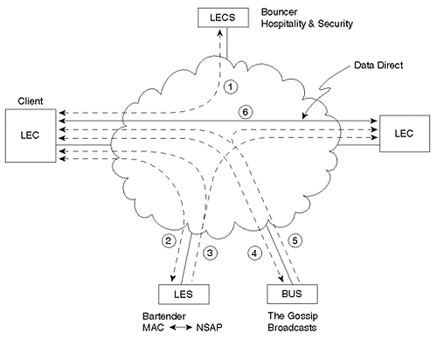

Using The LANE Bar as a Memory Aid
Because LANE obviously contains many unusual and complex mechanisms, use the LANE Bar analogy to keep your bearings. Many elements of the analogy were specifically chosen to mirror how LANE works in reality. In particular:
- Just as one physical building can be used to house two barrooms, one physical ATM cloud can house multiple ELANs.
- Just as a Bouncer provides security and hospitality, the LECS can check Client NSAP addresses for security and point the Clients toward the LES.
- Just as both barrooms were served by a single Bouncer, a single LECS serves an entire network.
- Just as each barroom required its own Bartender and Gossip, each ELAN requires a LES and BUS.
- Just as a Bartender runs a barroom, an LES runs an ELAN.
- Just as Gossips tell everyone everything they hear, BUSs are used to spray information to all Clients in an ELAN.
- Just as Clients are not allowed to come through the bar's back door when they are thrown out (they must dust themselves off and go back to see the Bouncer first), LANE Clients must rejoin an ELAN by visiting the LECS first.

Ethernet LANE Frame Format
Ethernet LANE traffic that passes over the Data Direct uses the frame format illustrated in Figure 9-15.

Figure 9-15 Ethernet Data Frame Format for LANE
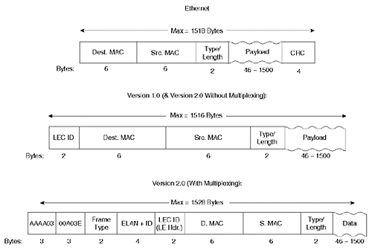
If you compare the LANE Version 1.0 format to the traditional Ethernet frame you will notice two changes:
- The addition of the 2-byte LEC ID field—
As LECs contact the LES, they are assigned a unique, 2-byte LECID identifier. In practice, the first LEC that joins is 1, the second is 2, and so on.
- The removal of the 4-byte CRC—
Because ATM has its own CRC mechanism, the ATM Forum removed the Ethernet CRC.
Notice that this changes the Ethernet MTU for LANE. As discussed in Chapter 1, the traditional Ethernet MTU is 1,518 bytes: 14 bytes of header, 1500 bytes of payload, and 4 bytes of CRC. Because Ethernet LANE removes the 4-byte CRC but adds a 2-byte LEC ID, the resulting MTU is 1516. However, notice that the payload portion is still 1500 bytes to ensure interoperability with all Ethernet devices.
LANE version 2.0 adds an optional 12-byte header to the front of the format used in version 1.0. The 12 bytes of this header are composed of the following four fields:
- 802.2 Logical Link Control (LLC) header—
The value AAAA03 signifies that the next five bytes are a SNAP header.
- SNAP Organizationally Unique Identifier (OUI) —
Used to specify the organization that created this protocol format. In this case, the OUI assigned to the ATM Forum, 00A03E, is used.
- SNAP Frame Type—
Used to specify the specific frame type. This field allows each of the organizations specified in the previous field to create up to 65,535 different protocols. In the LANE of LANE V2, the value 000C is used.
- LANE V2 ELAN ID—
A unique identifier for every ELAN.
This allows the second version of LANE to multiplex traffic from multiple ELANs over a single Data Direct VC (the ELAN-ID is used to differentiate the traffic).

Building a Data Direct VC
This section details the sequence of events that allow two Clients to establish a Data Direct VC. The example uses the network illustrated in Figure 9-16.

Figure 9-16 Two Ethernet Hosts Connected via Proxy Clients
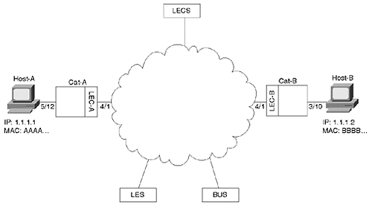
In the example, Host-A issues an IP ping to Host-B. Both devices are Ethernet-attached PCs connected to Catalysts that contain LANE uplink cards in slot 4. Host-A is using IP address 1.1.1.1 and MAC address AAAA.AAAA.AAAA. Host-B has IP address 1.1.1.2 and MAC address BBBB.BBBB.BBBB. Notice that this example focuses only on the building of a Data Direct—both Clients (Catalyst LANE cards) are assumed to have already joined the ELAN (using the five-step process discussed earlier). All caches and LANE tables are assumed to be at a state just after initialization. The following sequence outlines the steps that allow two Clients to establish a Data Direct VC.
Step 1. The user of Host-A enters ping 1.1.1.2 at a command prompt.
Step 2. Host-A issues an IP ARP for the IP address 1.1.1.2. Figure 9-17 illustrates this ARP packet.

Figure 9-17 IP ARP Request
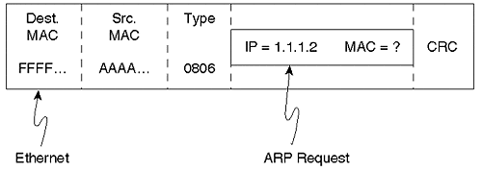
The ARP payload contains the destination IP address in question, 1.1.1.2, but contains all zeros for the associated MAC address. This ARP packet is then encapsulated in an Ethernet frame. As discussed in Chapter 2, "Segmenting LANs," the Ethernet encapsulation has a destination MAC address of FFFF.FFFF.FFFF and a source address of AAAA.AAAA.AAAA, the originating node.
Step 3. The LEC-A Catalyst receives the IP ARP frame on Port 5/12 and floods the frame out all ports in the same VLAN (there are no loops here, so Spanning Tree is ignored). Because LEC-A has been assigned to the same VLAN as Host-A, this Client needs to forward the frame across the LANE cloud. Because the destination address is FFFF.FFFF.FFFF, the Client forwards the frame to the BUS via the Multicast Send. Also notice that LEC-A adds an entry into its bridging table associating MAC address AAAA.AAAA.AAAA with Port 5/12.
Step 4. The BUS floods the packet to all Clients, including LEC-B, via the Multicast Forward. Notice that LEC-A also receives this frame, but is able to discard the frame because it recognizes its own LECID in the first two bytes.
Step 5. Because the LEC-B is operating as a transparent bridge, it also notices the broadcast destination address of the IP ARP and floods the packet to all ports in that VLAN, including Host-B's Port of 3/10. It also makes a new entry in its bridging table to reflect the fact that it just received a source MAC address of AAAA.AAAA.AAAA on Port 4/1.
Figure 9-18 illustrates the first five steps of the Data Direct Process.

Figure 9-18 The first five steps of the Data Direct VC Creation Process
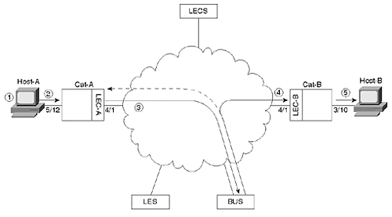
Step 6. Host-B receives the IP ARP request. Recognizing its IP address in the ARP packet, it builds an IP ARP reply packet. Figure 9-19 illustrates the reply.

Figure 9-19 IP ARP Reply
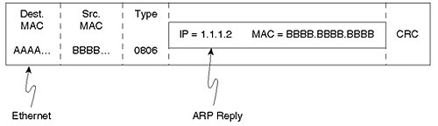
In this case, the ARP message contains the MAC address in question. Also notice that ARP unicasts the reply back to the source node; it is not sent to all nodes via the broadcast address.
Step 7. The LEC-B Catalyst receives the IP ARP reply. Having just added a bridging table entry for AAAA.AAAA.AAAA in Step 5, the frame is forwarded to the LANE module in slot 4.
Step 8. The LEC-B software running on the LANE module must then send the IP ARP reply over the ATM backbone. At this point, two separate threads of activities take over. The first thread, an LE_ARP process, is detailed in Step 8; the second thread, forwarding the IP ARP, is explained in Step 9.
- LEC-B must resolve MAC address AAAA.AAAA.AAAA into an NSAP address. To do this, LEC-B sends an LE_ARP_REQUEST to the LES. Notice the important differences between this LE_ARP and the earlier IP ARP. With the IP ARP, the destination IP address was known but the MAC address was not known. In the case of the LE_ARP, the MAC address is now known (via the IP ARP) and the NSAP address is unknown. In other words, the LE_ARP is only possible after the IP ARP has already resolved the MAC address.
- The LES consults its local MAC-address-to-NSAP-address mapping table. Although this table contains a mapping entry for LEC-A, it does not contain a mapping entry for Host-A.It is important to realize that LEC-A and Host-A are using different MAC addresses. Just because LEC-A is acting as a Proxy Client for Host-A doesn't mean that it has assumed Host-A's MAC address. When LEC-A joined the ELAN, it could have optionally registered all known addresses for its Ethernet-attached hosts. However, because transparent bridges rarely know all MAC addresses (after all, they are learning bridges), most vendors opt to only register the MAC address specifically assigned to the Proxy LEC.
If it still seems unclear why the LES wouldn't learn about MAC address AAAA.AAAA.AAAA at the time LEC-A joined the ELAN, consider the following: What if Host-A wasn't even running at the time LEC-A joined? In this case, the MAC address isn't even active, so it is impossible for LEC-A to register MAC address AAAA.AAAA.AAAA.
- Because the LES doesn't have a mapping for the requested MAC address, it forwards the LE_ARP message on to all Proxy Clients via the Control Distribute VC.
Figure 9-20 diagrams Steps 6 through 8c.

Figure 9-20 Steps 6–8c in the Data Direct VC Creation Process
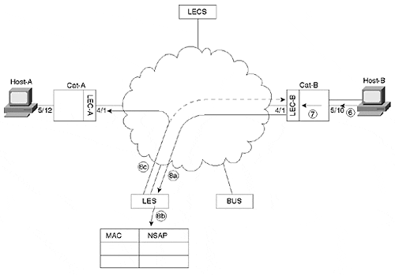
- All Clients, including LEC-A, receive the LE_ARP_REQUEST. LEC-A answers with an LE_ARP_REPLY using the bridging table entry added in Step 3.
- The LES receives the LE_ARP_REPLY from LEC-A and forwards it to LEC-B.
- LEC-B builds a Data Direct VC to LEC-A.
Figure 9-21 illustrates Steps 8d through 8f.

Figure 9-21 Steps 8d–8f in the Data Direct VC Creation Process
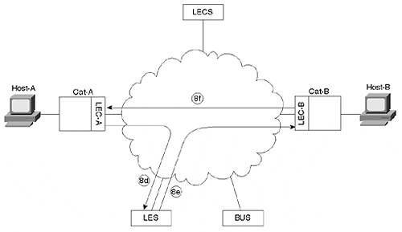
Step 9. As mentioned in Step 8, LEC-B performed two tasks in parallel. Steps 8a through 8f detailed the LE_ARP resolution process. However, while this sequence of events was taking place, LEC-B also forwarded the IP ARP frame via the BUS. Steps 9a through 9f detail this process of forwarding the IP ARP.
- LEC-B sends the IP ARP frame over its Multicast Send to the BUS.
- The BUS forwards this frame to all Clients via the Multicast Forward.
- All Clients, including LEC-A, receive the IP ARP packet. LEC-B recognizes its LECID and drops the frame. LEC-A uses the bridging table entry added in Step 3 to forward the IP ARP out Port 5/12 to Host-A. LEC-A also adds a bridging table entry associating Port 4/1 with MAC address BBBB.BBBB.BBBB.
Figure 9-22 illustrates Steps 9a through 9c.

Figure 9-22 Steps 9a–9c in the Data Direct VC Creation Process
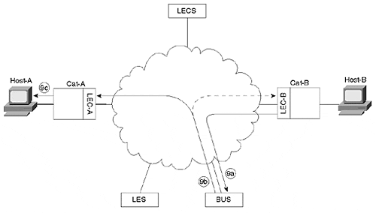
- Having received the IP ARP reply, Host-A caches the IP ARP data, and sends the IP ping packet that has been waiting since Step 2. The destination MAC address is BBBB.BBBB.BBBB (a unicast frame).
- The LEC-A Catalyst receives the ping packet on Port 5/12 and uses the bridging table entry added in Step 9c to forward the frame out Port 4/1.
- LEC-A then performs the same two parallel tasks discussed in the text preceding Step 8: it issues an LE_ARP_REQUEST over the Control Direct to build a Data Direct, and it floods the ping packet via the BUS. Although the intervening steps are not shown, LEC-A ultimately receives an LE_ARP_REPLY.
- LEC-A uses the information contained in the LE_ARP_REPLY to build a Data Direct VC to LEC-B.
Figure 9-23 illustrates the remaining portions of Step 9.

Figure 9-23 Steps 9d–9g in the Data Direct VC Creation Process
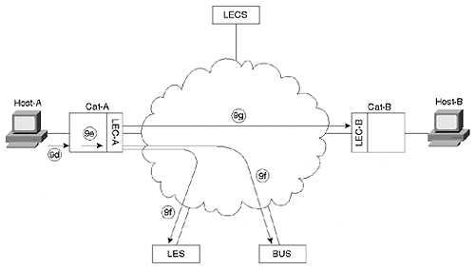
Step 10. At this point, both LECs have attempted to build a Data Direct VC. Which Data Direct VC is built first can be different in every case and depends on the timing of Steps 8 and 9. Assume that LEC-B completes its Data Direct VC first and the timing is such that LEC-A also builds a Data Direct VC. In this case, both LECs begin using the Data Direct VC built by the LEC with the lower NSAP address. Assume that LEC-A has the lower NSAP. This causes all traffic to flow over the Data Direct VC created by LEC-A (LEC-B's Data Direct VC times out after five minutes by default on Cisco equipment).
Step 11. Before the Clients can begin communicating, they must take an extra step to ensure the in-order delivery of information. Notice that both LEC-B (Step 9b) and LEC-A (Step 9f) have sent information via the BUS. If the Clients were to start sending information via the Data Direct VC as soon as it became available, this could lead to out-of-order information. For example, the Data Direct frame (the second frame sent) could arrive before the frame sent via the BUS (the first frame sent). To prevent this, the Clients can optionally use a Flush protocol. Steps 11a–11e follow the Flush protocol from LEC-A's perspective:
- LEC-A sends an LE_FLUSH_REQUEST message over the Multicast Send.
- The BUS forwards the LE_FLUSH_REQUEST to LEC-B.
- LEC-B answers the Flush with a LE_FLUSH_RESPONSE over the Control Direct.
- The LES forwards the LE_FLUSH_RESPONSE over the Control Direct to LEC-A.
- Having now flushed all data out of its connection to the BUS, LEC-A can safely begin using the Data Direct VC. The remaining ping packets use this Data Direct VC.
Figure 9-24 diagrams the Data Direct VC completion and Flush processes.

Figure 9-24 Steps 10 and 11a–11e in the Data Direct VC Creation Process
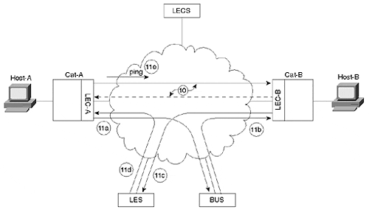
Notice that after the process forks in Step 8, the order of the events becomes indeterminate. In some cases, LEC-A is the first to build a Data Direct VC; in other cases, LEC-B is the first.

Configuration Concepts
There are several important concepts used in configuring LANE on Cisco devices, including the following:
- Mapping VLAN numbers to ELAN names
- Addressing
- Subinterfaces

Mapping VLAN Numbers to ELAN Names
Whereas the Catalyst refers to broadcast domains with VLAN numbers, LANE always uses textual ELAN names. The LEC is used to map the VLAN number into an ELAN name (as is discussed in the "Configuration Syntax" section later, this mapping is established via the command that creates the Client). ELAN names can be up to 32 characters in length. Be very careful when configuring ELAN names because they are case sensitive.

Subinterfaces
As explained in Chapter 8, "Trunking Technologies and Applications," Cisco uses the subinterface concept to create logical partitions on a single physical interface. In this case, each partition is used for a separate ELAN as shown in Figure 9-25.

Figure 9-25 Each Subinterface Is Used for a Separate ELAN
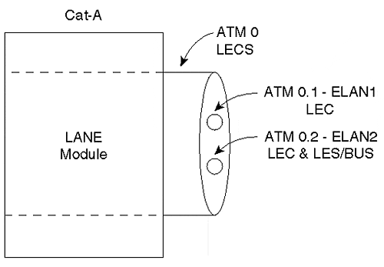
In Figure 9-25, subinterface ATM 0.1 is used for ELAN1, and ATM 0.2 is used for ELAN2. Cat-A is a client on both ELANs and therefore requires a LEC on both subinterfaces. Because Cat-A is also acting as the LES and BUS for ELAN2 (but not ELAN1), these services are only configured on subinterface ATM 0.2. However, notice that the LECS is configured on the major interface, ATM 0. This placement mirrors the roles that each component plays:
- Because the LECS doesn't belong to any particular ELAN, it is placed on the major interface. As a global concept, the LECS should be placed on the global interface.
- LECs, LESs, and BUSs that do belong to specific ELANs are placed on subinterfaces.
In short, subinterfaces allow the interface configuration to match the LANE configuration.
Tip
Although most LANE components are configured on a subinterface, the LECS is always configured on the major interface of Cisco equipment.

Addressing
LANE's reliance on SVCs requires careful planning of NSAP addresses (recall that SCVs are built by placing an ATM phone call to an NSAP address). Although Cisco allows you to manually configure NSAP addresses, an automatic NSAP addressing scheme is provided to allow almost plug-and-play operation.
Recall from Figure 9-6 that NSAP addresses have three sections:
- A 13-byte prefix from the ATM switch (LS1010)
- A 6-byte ESI from the edge device (Catalyst LANE module)
- A 1-byte selector byte from the edge device (Catalyst LANE module)
The LANE components automatically acquire the prefix from the ATM switch. However, what does the Catalyst provide for the ESI and selector byte values? Cisco has created a simple scheme based on MAC addresses to fulfill this need. Every ATM interface sold by Cisco has a block of at least eight MAC addresses on it (some interfaces have more). This allows each LANE component to automatically adopt a unique NSAP address using the pattern shown in Table 9-3.

Table 9-3. Automatic ESI and Selector Byte Values
LANE Component | ESI | Selector Byte
LEC | MAC Address | .**
LES | MAC Address + 1 | .**
BUS | MAC Address + 2 | .**
LECS | MAC Address + 3 | .00
** Represents the subinterface where a LANE component is created
For example, assume that an ATM switch is using a prefix of 47.0091.8100.0000.0060.1234.5678 and the first MAC address on a LANE blade is 0000.0CAB.5910. If you build all four components on this device and use subinterface ATM 0.29, Table 9-4 shows the resulting NSAP addresses.

Table 9-4. Sample NSAP addresses
LANE Component | NSAP
LEC | 47.0091.8100.0000.0060.1234.5678.0000.0CAB.5910.1D
LES | 47.0091.8100.0000.0060.1234.5678.0000.0CAB.5911.1D
BUS | 47.0091.8100.0000.0060.1234.5678.0000.0CAB.5912.1D
LECS | 47.0091.8100.0000.0060.1234.5678.0000.0CAB.5913.00
As discussed earlier, notice that the LECS always appears on the major interface and uses .00 as a selector byte. Also note that although subinterfaces are expressed in decimal to the IOS (interface ATM 0.29), the selector byte is expressed in hexadecimal (0×1D).
Tip
Although subinterface numbers are expressed in decimal in the IOS configuration, they are expressed in hex when used for the ATM NSAP's selector byte.

In practice, Cisco makes it extremely easy to determine the NSAP addresses for a specific Catalyst LANE module—just use the show lane default command. For example, the Catalyst output in Example 9-1 is connected to an ATM switch with the prefix 47.0091.8100.0000.0010.2962.E801.

Example 9-1 Determining NSAP Addresses for a Catalyst LANE Module
ATM#show lane default interface ATM0: LANE Client: 47.00918100000000102962E801.00102962E430.** LANE Server: 47.00918100000000102962E801.00102962E431.** LANE Bus: 47.00918100000000102962E801.00102962E432.** LANE Config Server: 47.00918100000000102962E801.00102962E433.00 note: ** is the subinterface number byte in hex
The selector byte is shown as .** for the LEC, LES, and BUS because the subinterface numbers are not revealed by this command.

Configuration Syntax
The good news is that, although the theory of LANE is very complex and cumbersome, Cisco has made the configuration very simple. In fact, LANE uses the same configuration syntax across almost the entire product line. In other words, learn how to configure LANE on a Catalyst and you already know how to configure it on a Cisco router or ATM switch.
To configure a Catalyst LANE module, you must first use the session command to open a LANE command prompt. For example, if you currently have a Telnet session into the Catalyst 5000 Supervisor and you want to configure a LANE blade in slot 4, you issue the command in Example 9-2.

Example 9-2 Opening a LANE Command Prompt
MyCat> (enable) session 4 Trying ATM-4… Connected to ATM-4. Escape character is '^]'. ATM>
This suddenly catapults you to the IOS-style command prompt on the LANE module! That's right, the LANE module runs the traditional IOS software (although it's obviously a separate binary image that must be downloaded from CCO). Almost all of the router's command-line interface (CLI) features you know and love are available:
- BASH-style command-line recall (using the arrow keys)
- config term to alter the configuration
- debug commands
- copy run start or write mem to save the configuration
Don't forget the last bullet: unlike the Catalyst Supervisor, you must remember to save the configuration. Forget to do this and you are guaranteed to have a miserable day (or night) after the next power outage!
Tip
Don't forget to use the copy run start command to save your LANE configuration!

It is easiest to think of the LANE module as an independent device that connects to the Catalyst backplane. In other words, it has its own DRAM and CPU for use while operational. When the Catalyst is powered down, the LANE module uses its own NVRAM to store the configuration and flash to store the operating system.
The Catalyst LANE module can be configured in five simple steps, each of which are detailed in the sections that follow:
Step 1. Build overhead connections
Step 2. Build the LES and BUS
Step 3. Build the LECS
Step 4. Build the LECs
Step 5. Add LECS' NSAP to ATM Switch

Step 1: Build Overhead Connections
LANE makes extensive use of the ATM overhead protocols mentioned earlier in the chapter. Specifically, the LEC must be configured to use signaling and ILMI. Signaling allows the LEC to build the many SVCs required by LANE, whereas ILMI provides address registration and allows the ATM switch to provide the LECS' (Bouncer's) NSAP address. Both of these overhead protocols are enabled by creating two ATM PVCs. The basic syntax for the ATM PVC commands is (there are other options available, but they are not relevant to LANE) as follows:

atm pvc VCD VPI VCI encapsulation

The VCD parameter is used to specify a locally significant Virtual Circuit Descriptor. The IOS uses a unique VCD to track every ATM connection. In the case of PVCs, you must manually specify a unique value. In the case of SVCs, the Catalyst automatically chooses a unique value.
The VPI and VCI parameters are used to specify the Virtual Path Indicator and Virtual Channel Indicator, respectively. Recall that these are the two addressing fields in the 5-byte ATM cell header.
The two PVCs listed in Example 9-3 must exist on every LEC.

Example 9-3 Mandatory PVCs for LECs
ATM(Config)# int atm 0 ATM(Config-if)# atm pvc 1 0 5 qsaal ATM(Config-if)# atm pvc 2 0 16 ilmi
The first PVC provides signaling (QSAAL stands for Q.Signaling ATM Adaptation Layer), whereas the second PVC obviously provides ILMI. You are free to use any VCD values you want; however, they must be unique, and the values 1 and 2 are most common.
Be careful not to enter commands in Example 9-4.

Example 9-4 Eliminating a PVC by Mistake
ATM(Config)# int atm 0 ATM(Config-if)# atm pvc 1 0 5 qsaal ATM(Config-if)# atm pvc 1 0 16 ilmi
This common mistake results in only one PVC (ILMI) because the VCD numbers are the same.
The best news of all is that Step 1 is not required for Catalyst LANE modules! All Catalyst LANE images since 3.X automatically contain the two overhead PVCs. On the other hand, if you are configuring LANE on a Cisco router, don't forget to enter these two commands.
Tip
The ATM PVC statements for signaling and ILMI are not required for Catalyst LANE module configuration. However, they are required for LANE configurations on Cisco routers.

Step 2: Build the LES and BUS (Bartender and Gossip)
The first LANE-specific components to be configured are the LES and BUS (you can create the LANE components in any order you want, however, I recommend the order presented here). To allow the components to function more efficiently, Cisco requires the LES and BUS to be co-located on the same device. Therefore, a single command is used to enable both devices:

lane server-bus ethernet ELAN_Name

For example, the configuration in Example 9-5 creates a LES and BUS for the ELAN named ELAN1.

Example 9-5 Creating the LES and BUS for an ELAN
ATM(Config)# int atm 0.1 multipoint ATM(Config-subif)# lane server-bus ethernet ELAN1
Caution
Enter ELAN names carefully—they are case sensitive.

After completing the configuration in Example 9-5, you should be able to view the status of the LES with the show lane server command as demonstrated in Example 9-6.

Example 9-6 Viewing the LES Status
ATM#show lane server LE Server ATM0.1 ELAN name: ELAN1 Admin: up State: operational type: ethernet Max Frame Size: 1516 ATM address: 47.00918100000000102962E801.00102962E431.01 LECS used: 47.007900000000000000000000.00A03E000001.00 NOT yet connected
Finally, be sure to make note of the LES' address on the second to last line (the ATM address: field), it is used in Step 3.
Unless you are using SSRP server redundancy (discussed later), be sure to only configure one LES/BUS for each ELAN.

Step 3: Build the LECS (Bouncer)
Every LANE network requires a single LECS (although redundant LECSs are possible using SSRP). The LECS is configured using a two-step process:
Step 1. You must build the LECS database.
Step 2. You must enable the LECS on the major interface.

Building the LECS Database
The LECS database is a table that lists all of the available ELANs and their corresponding LES NSAP addresses. It can also list optional information such as NSAP addresses for security verification and ELAN IDs. To create a basic LECS database, use the lane database command to enter the database configuration mode of the IOS CLI. The following is the syntax for the lane database command:

lane database database-name

At this point, you can now enter one line per ELAN. Each line lists the name of the ELAN and the NSAP of the LES for that ELAN using the following syntax (some advanced options have been omitted for simplicity):

name elan-name server-atm-addres atm-addr

Note
Multiple lines are possible if you are using a feature known as SSRP. This option is discussed later.

For example, the commands in Example 9-7 build a database for two ELANs.

Example 9-7 Building a Database for Two ELANS
ATM(Config)# lane database My_LECS_Db ATM(lane-config-database)# name ELAN1 server-atm-address 47.00918100000000102962E801.00102962E431.01 ATM(lane-config-database)# name ELAN2 server-atm-address 47.00918100000000102962E801.00101F266431.02
A common mistake is to configure the NSAP of the LECS in the database (instead of the LES' NSAP). The LECS doesn't need to have its own address added to the database (it already knows that), it needs to know the NSAP of the LES. Just remember, the LECS (Bouncer) needs to tell Clients how to reach the LES (Bartender).
Tip
Be certain that you specify the name of the LES, not the LECS, in the LECS database.

Be aware that the capability to edit the LECS database on the ATM device itself is a very useful Cisco-specific feature. Several other leading competitors require you to build the file on a TFTP server using cryptic syntax and then TFTP the file to the ATM device, an awkward process at best.

Enabling the LECS
After you have built the LECS, you can enable the LECS. As discussed earlier, the LECS must run on a major interface because it is a global component that serves the entire network and does not belong to any particular ELAN.
You must enter the two required commands in Example 9-8 to start the LECS.

Example 9-8 Required Commands for Starting the LECS
ATM(Config)# int atm 0 ATM(Config-if)# lane config database My_LECS_Db ATM(Config-if)# lane config auto-config-atm-address
The lane config database command binds the database built in the previous step to the specified major interface. The complete syntax for this command is as follows:

lane config database database-name

The lane config auto-config-atm-address command tells the IOS to use the automatic addressing scheme (MAC Address + 3 . 00) discussed earlier. The following is the complete syntax for this command:

lane config auto-config-atm-address

Step 4: Build the LECs (Clients)
The fourth step adds LANE Clients to the appropriate subinterfaces. If a single Catalyst LANE module needs to participate in ten ELANs, it requires ten Clients. To create a single client, issue the command in Example 9-9.

Example 9-9 Creating an LEC
ATM(Config)# int atm 0.1 multipoint ATM(Config-subif)# lane client ethernet 1 ELAN1
The 1 ties VLAN 1 to ELAN1, merging the two into a single broadcast domain.
The following is the complete syntax for the lane client command:

lane client [ethernet | tokenring] vlan-num [elan-name]

Tip
It is necessary to specify a VLAN number to ELAN name mapping when creating a LEC on a Catalyst LANE module. This is not required when configuring LANE on a Cisco router (by default, they route, not bridge, between the LEC and other interfaces).

Step 5: Add the LECS' NSAP to ATM Switch
Recall that Cisco devices prefer to have LECs learn the NSAP of the LECS via ILMI. This requires that ATM switches be configured with the LECS' NSAP address. To do this, enter the following command on the LS1010 (the LS1010 also uses an IOS-style interface):

Switch(Config)# atm lecs-address-default 47.0091.8100.0000.0010.2962.
e801.0010.2962.e433.00

This is a global command that applies to all ports on the switch. You can obtain the LECS' address by issuing the show lane config command or the show lane default command on the device functioning as the Configuration Server. This command must be configured on all ATM switches (there is not an automated protocol to disseminate the LECS' NSAP between ATM switches). The full syntax of the atm lecs-address-default command is as follows:

atm lecs-address-default lecs-address [sequence-#]

The sequence-# parameter is used by the SSRP feature discussed later in the chapter.

A Complete LANE Network
Figure 9-26 pulls together many of the concepts and commands discussed earlier in previous sections. This section also shows the configuration for an ATM-attached router.

Figure 9-26 A Complete LANE Network
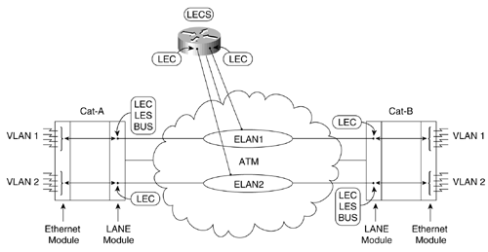
The network consists of two Catalysts that contain Ethernet and LANE modules. Each Catalyst has been configured with two VLANs that use ATM as a trunk media. VLAN 1 is transparently bridged to ELAN1, creating a single broadcast domain. VLAN 2 uses ELAN2. Both Catalysts have two LANE Clients, one for each ELAN. Cat-A is acting as the LES/BUS for ELAN1, and Cat-B is serving as the LES/BUS for ELAN2. Example 9-10 shows the configuration code for Cat-A.

Example 9-10 Cat-A Configuration for the LANE Network in Figure 9-26
int atm 0 atm pvc 1 0 5 qsaal atm pvc 2 0 16 ilmi ! int atm 0.1 multipoint lane server-bus ethernet ELAN1 lane client ethernet 1 ELAN1 ! int atm 0.2 multipoint lane client ethernet 2 ELAN2
Example 9-11 shows the configuration code for Cat-B.

Example 9-11 Cat-B Configuration for the LANE Network in Figure 9-26
int atm 0 atm pvc 1 0 5 qsaal atm pvc 2 0 16 ilmi ! int atm 0.1 multipoint lane client ethernet 1 ELAN1 ! int atm 0.2 multipoint lane server-bus ethernet ELAN2 lane client ethernet 2 ELAN2
An ATM-attached router on a stick has also been configured to provide routing services between the VLANs/ELANs. To function in this capacity, the router must be configured with the two overhead PVCs on the major interface and two subinterfaces containing LANE Clients and IP addresses. The router is also acting as the LECS for the network. Example 9-12 shows the configuration code for the router.

Example 9-12 Router Configuration for the LANE Network in Figure 9-26
lane database my_database name ELAN1 server-atm-address 47.0091.8100.0000.0010.2962.E801.0010.2962.E431.01 name ELAN2 server-atm-address 47.0091.8100.0000.0010.2962.E801.0010.1F26.6431.02 ! int atm 1/0 atm pvc 1 0 5 qsaal atm pvc 2 0 16 ilmi lane config database my_database lane config auto-config-atm-address ! int atm 1/0.1 multipoint ip address 10.0.1.1 255.255.255.0 lane client ethernet 1 ELAN1 ! int atm 1/0.2 multipoint ip address 10.0.2.1 255.255.255.0 lane client ethernet 2 ELAN2

Testing the LANE Configuration
At this point, you should have a working LANE configuration. Use the show lane client command to troubleshoot your configuration—it is a deceptively powerful and useful command. Notice that, for two reasons, I recommend using show lane client before you even try a ping. First, the LANE module does not have a ping command (requiring that you use the exit command to return to the Supervisor). Second, show lane client provides much more useful information.
Example 9-13 demonstrates the show lane client display from a working configuration.

Example 9-13 show lane client Command Output
ATM#show lane client LE Client ATM0.1 ELAN name: ELAN1 Admin: up State: operational Client ID: 3 LEC up for 8 seconds Join Attempt: 1 HW Address: 0010.2962.e430 Type: ethernet Max Frame Size: 1516 VLANID: 1 ATM Address: 47.00918100000000102962E801.00102962E430.01 VCD rxFrames txFrames Type ATM Address 0 0 0 configure 47.00918100000000102962E801.00102962E433.00 22 1 3 direct 47.00918100000000102962E801.00102962E431.01 23 7 0 distribute 47.00918100000000102962E801.00102962E431.01 25 0 1 send 47.00918100000000102962E801.00102962E432.01 26 6 0 forward 47.00918100000000102962E801.00102962E432.01
The breakdown for the output in Example 9-13 is as follows:
- The first line (after the show lane client command, of course) shows the subinterface, the ELAN name, whether the LEC is administratively up, and whether the LEC is in an operational state.
- The second line shows the LEC-ID assigned by the LES to this LEC and how long the LEC has been active.
- The third line displays how many attempts it took the LEC to join (in some cases, this information might appear at the end of the second line).
- The fourth line shows the MAC address being used by the Client (it should tie to the first line in show lane default), whether the LEC is an Ethernet or Token Ring Client, and the MTU being used.
- The VLAN mapped to the ELAN specified in the first line generally wraps on the display to be shown on the fifth line.
- The sixth line shows the NSAP address being used by the LEC (if you have used the auto-NSAP addresses, it should include the MAC address on line four as the ESI).
- The remaining output shows the five overhead connections created during the joining process. Notice that they are shown in the order they are created. Remember to use this great reference tool when you forget the joining order! Each line shows the VCD currently in use for that connection, the number of frames transmitted and received on that connection, the name of the connection (abbreviated), and the NSAP of the device at the other end of the connection. Notice that the Configuration Direct VC to the Configuration Server has a VCD of 0. This reflects the fact that Cisco closes this control connection as soon as the LECS has provided the NSAP of the LES. As Data Direct VCs are built, they appear as additional lines after the five overhead VCs.
Tip
Use the show lane client command to remember the order of the LANE joining process.

There are several items in Example 9-13 showing that the LEC has successfully joined the ELAN:
- The State is operational.
- The LEC has been up for eight seconds.
- All five overhead VCs have valid NSAPs listed.
Example 9-14 shows a common failure condition.

Example 9-14 LEC Failure
ATM#show lane client LE Client ATM0.1 ELAN name: ELAN1 Admin: up State: initialState Client ID: unassigned Next join attempt in 9 seconds Join Attempt: 7 Last Fail Reason: Config VC being released HW Address: 0010.2962.e430 Type: ethernet Max Frame Size: 1516 VLANID: 1 ATM Address: 47.00918100000000102962E801.00102962E430.01 VCD rxFrames txFrames Type ATM Address 0 0 0 configure 47.007900000000000000000000.00A03E000001.00 0 0 0 direct 00.000000000000000000000000.000000000000.00 0 0 0 distribute 00.000000000000000000000000.000000000000.00 0 0 0 send 00.000000000000000000000000.000000000000.00 0 0 0 forward 00.000000000000000000000000.000000000000.00
Several sections of the output in Example 9-14 point to the failure, including:
- The State is initialState.
- The LEC attempts to join again in nine seconds.
- A Last Fail Reason is provided.
- Only the first VC (the Configuration Direct) lists a non-zero NSAP.
Because the first line represents the Configuration Direct to the LECS, the information in this display is strong evidence of a problem very early in the joining process. Also look carefully at the NSAP for the Configuration Direct—it is the well-known NSAP. Because Cisco uses the well-known NSAP as a last gasp effort to contact the LECS if all other measures have failed, it is often a sign that the join process failed. In fact, this display is almost always the result of three specific errors:
- The ATM switch provided the wrong NSAP (or no NSAP) for the LECS—
When the LEC contacted the device specified by this NSAP and tried to begin the joining process, it was rudely told the equivalent of "Join an ELAN?? I don't know what you are talking about!" Look at the atm lecs-address-default command on the LS1010 to verify and fix this problem.
- The LEC was given the correct NSAP address LECS, but the LECS is down—
In this case, the Client contacted the correct devices, but it was still rebuffed because the LECS couldn't yet handle LE_CONFIGURE_REQUESTS (the message sent between Clients and LECSs). Look at the configuration of the LECS to verify and fix this problem. The show lane config command is often useful for this purpose.
- The LEC requested an ELAN that doesn't exist—
To verify this condition, issue a terminal monitorcommand on the LANE module to display error messages. If you see "CFG_REQ failed, no configuration (LECS returned 20)" messages, use the show lane client command to check the ELAN name. Make certain that this ELAN name is identical to one of the ELANs displayed in show lane database on the LECS. Carefully check for incorrect case—ELAN names are case sensitive.
The output in Example 9-15 shows the results of an LEC that made it past contacting the LECS but has run into problems contacting the LES.

Example 9-15 LEC Can't Contact LES
ATM#show lane client LE Client ATM0.1 ELAN name: ELAN1 Admin: up State: initialState Client ID: unassigned Next join attempt in 10 seconds Join Attempt: 8 Last Fail Reason: Control Direct VC being released HW Address: 0010.2962.e430 Type: ethernet Max Frame Size: 1516 VLANID: 1 ATM Address: 47.00918100000000102962E801.00102962E430.01 VCD rxFrames txFrames Type ATM Address 0 0 0 configure 47.00918100000000102962E801.00102962E433.00 0 0 0 direct 47.00918100000000102962E801.00102962E431.01 0 0 0 distribute 00.000000000000000000000000.000000000000.00 0 0 0 send 00.000000000000000000000000.000000000000.00 0 0 0 forward 00.000000000000000000000000.000000000000.00
The output in Example 9-15 shows most of the same symptoms as the output in Example 9-14; however, the first two overhead connections have NSAPs listed. For two reasons, this pair of overhead connections proves that the LEC successfully reached the LECS. First, the Configuration Direct (first overhead circuit) lists the correct NSAP for the LECS. Second, the LEC could not have attempted a call to the LES (second overhead circuit) without having received an NSAP from the LECS. In this case, the LEC called the LES (Control Direct, second VC), but the LES didn't call the LEC back (Control Distribute, third VC). This diagnosis is further supported by the Last Fail Reason indicating "Control Direct VC being released." In almost all cases, one of two problems is the cause:
- The LEC received the incorrect NSAP address for the LES from the LECS—
The LEC again "jumped off in the weeds" and called the wrong device only to receive an "I don't know what you're talking about!" response. Use the show lane database command on the LECS to verify LES' NSAP addresses for the appropriate ELAN. If necessary, correct the LECS database.
- The LEC was given the right NSAP address for the LES, but the LES is down—
The LEC called the correct device, but the device was not a functioning LES. Verify the problem with the show lane server command on the LES (make certain that the LES is operational). If necessary, adjust the LES configuration parameters.
It is very uncommon to have a problem with only the Multicast Send and Multicast Forward VCs on Cisco equipment. Such behavior suggests a problem with the BUS: either the LES provided the wrong NSAP for the BUS or the BUS was not active. Because Cisco requires that the LES and BUS be co-located, the BUS should always be reachable if the LES is reachable. However, if you are using a third-party device for the LES and BUS, it is possible to run into this problem.
If you are still not able to successfully join the ELAN, consult the more detailed information given in Chapter 16, "Troubleshooting." Chapter 16 explores additional troubleshooting techniques.

Advanced LANE Issues and Features
This section explores several advanced issues that might be relevant in large LANE networks, including the following:
- Where to run LANE services
- Using hard-coded addresses
- SSRP
- Dual-PHY
- Using the well-known NSAP for LECS discovery
- PVCs and traffic shaping

Where to Run LANE Services
One of the first questions facing most implementers of LANE is "Where should I locate my three server components (LECS, LES, and BUS)?"
Because the LECS function is a very low-CPU function, you have a fair amount of latitude in terms of where you place the LECS. The main criterion is to pick a device with high availability. Some network designers argue that the best location is an ATM switch because it provides a centrally-located database. However, other designers argue that during a partial network outage, the ATM switch has its hands full just trying to build new SVCs. To further burden it with handling LECS duties hampers network resiliency. I generally try to locate the LECS in a Catalyst LANE module. However, a platform such as a 7500 router can also be a good choice.
The LES function requires more CPU effort than the LECS function, but it is generally not a burdensome amount. On the other hand, the BUS does require a tremendous amount of effort—it must be able to handle all broadcasts and all multicasts on the network while also supporting unicast traffic until the Flush process can occur. Because Cisco requires the LES to be co-located with the BUS, the BUS becomes the component that must be carefully positioned. In practice, the Catalyst 5000 currently provides the best BUS performance of the Cisco product line (as well as having top performance within the industry). Table 9-5 shows the BUS performance for various Cisco ATM devices expressed in kilopackets (thousands of packets) per second. When released, the Catalyst 6000 OC-12 ATM module is expected to have performance comparable to that of the Catalyst 5000 OC-12 module.

Table 9-5. BUS Performance by Hardware Platform (in Kilopackets per Second)
Platform | KPPS
Catalyst 5000 OC-12 LANE Module | 500+
Catalyst 5000 OC-3 LANE Module | 125
ATM PA (in 7500 and 7200) | 70
Catalyst 3000 | 50
4700 NMP-1A | 41
LS1010 | 30
7000 AIP | 27
Note
Although Catalyst LANE modules provide the highest throughput in Cisco's products line, routers with very powerful CPUs (such as the 7500 RSP4) can provide faster recovery during network failover (the additional CPU capacity allows them to build VCs more quickly). In general, this is less important than the throughput numbers presented in Table 9-5.

Using Hard-Coded Addresses
Although the automatic NSAP scheme based on MAC addresses and subinterface numbers does allow for very easy configuration of LANE across Cisco devices, it can lead to maintenance problems. Because the MAC addresses used for the NSAP scheme are tied to the chassis or Supervisor module, swapping cards can create a need for minor reconfigurations. Chassis that support redundant Supervisors such as the 55XX family derive their MAC address from chips located on the backplane. Each slot is assigned a block of addresses, causing problems if either the chassis is changed or the LANE module is moved to a different slot. Chassis that only support a single Supervisor engine (such as the Catalyst 5000) pull their MAC addresses from the Supervisor module itself. Again, each slot is assigned a block of addresses. However, in this case, problems do not result from a change in the chassis (after all, the backplane in these platforms is passive) but from a change in Supervisor modules or if the LANE module is moved to another slot.
Note that reconfiguration is only required if the device acting as the LECS or the LES is changed. If the LECS changes, you need to modify the NSAP address configured on every ATM switch (but, assuming ILMI or well-known LECS NSAPs are in use, this does not require a change on the LECs). If the LES changes, you need to modify the LES' NSAP listed in the LECS database.

SSRP
The LANE 1.0 spec released in January 1995 did not provide for a server-to-server protocol (known as the LNNI [LANE Network-Network Interface] protocol). Because this limitation prohibited multiple servers from communicating and synchronizing information with each other, the ATM Forum had a simple solution: allow only a single instance of each type of server. The entire network was then dependent on a single LECS, and each ELAN was dependent on a single LES and BUS. Because this obviously creates multiple single points of failure, most ATM vendors have created their own redundancy protocols. Cisco's protocol is known as the Simple Server Redundancy Protocol (SSRP).
SSRP allows for an unlimited number of standby LECS and LES/BUS servers, although one standby of each type is most common. It allows the standby servers to take over if the primary fails, but it does not allow multiple active servers. One of the primary benefits of SSRP is that it is interoperable with most third-party LECs.
An additional benefit of SSRP is that it is easy and intuitive to configure. To provide for multiple LECSs, you simply need to configure multiple atm lecs-address-default commands on every ATM switch. To provide for multiple LES/BUSs for every ELAN, just add multiple name ELAN_NAME server-atm-address NSAP commands to the LECS database. For example, the commands in Example 9-16 configure two LECSs on a LS1010 ATM switch.

Example 9-16 Configuring Two LECSs on a LS1010 ATM Switch
Switch(Config)# atm lecs-address-default 47.0091.8100.0000.0010.2962. e801.0010.2962.e433.00 Switch(Config)# atm lecs-address-default 47.0091.8100.0000.0010.29BC. 5604.0010.2972.7713.00
If the first LECS is available, the LS1010 always provides this address to LECs via ILMI. However, if the first LECS becomes unavailable, the ATM switch just returns the second LECS' NSAP to the LEC. Other than an address change, the LEC doesn't even know the first LECS failed.
Caution
You must be certain to enter redundant LECS addresses in the same order on all ATM switches.

The commands in Example 9-17 configure redundant LES/BUS servers for ELAN1 and ELAN2.

Example 9-17 Configuring Redundant LES/BUS Servers for Multiple ELANs
ATM(Config)# lane database My_LECS_Db ATM(lane-config-database)# name ELAN1 server-atm-address 47.00918100000000102962E801.00102962E431.01 ATM(lane-config-database)# name ELAN1 server-atm-address 47.009181000000001029BC5604.001029727711.01 ATM(lane-config-database)# name ELAN2 server-atm-address 47.00918100000000102962E801.00101F266431.02 ATM(lane-config-database)# name ELAN2 server-atm-address 47.009181000000001029BC5604.00101F727711.02
If the first LES listed is available, the LECS returns this address to the LEC in the LE_CONFIGURE_REPLY. If the first LES fails, the LECS returns the second LES' NSAP when the LEC tries to rejoin. Again, the LEC isn't aware of the change (other than it was given a different address).
Caution
Make certain that all of the LECS database are identical.

The LECS redundancy mechanism is implemented by control connections between the LECSs. The LECS uses ILMI to acquire the complete list of LECSs servers from the ATM switch (just as an LEC does). Each LECS then builds an SVC to every LECS listed below itself on the list. The one LECS with no inbound connections is the primary LECS. However, if the primary fails, its connection to the second LECS closes, causing the second LECS to no longer have any inbound connections. For example, imagine three LECS devices A, B, and C. A is listed first on the LS1010 and C is listed last. After all three switches acquire the complete list of LECSs via ILMI, the A device opens a connection to B and C, and B opens a connection to C. Because B has one inbound connection and C has two inbound connections, both of these devices are backup LECSs. Because it has no inbound connections, A becomes the primary LECS. However, if A fails, the connection to B fails causing B to become the primary. If B fails, its connection to C drops and C becomes the primary.
The LES/BUS redundancy mechanism also utilizes ILMI. Upon startup, all LES/BUSs use ILMI to locate the primary LECS. Every LES/BUS then builds a connection to this single LECS. The Configuration Server then evaluates all of the inbound connections to determine which connection is from the LES/BUS listed first in the LECS database. That LES/BUS' NSAP is then provided in LE_CONFIGURE_REPLY messages to LANE Clients.

Dual-PHY
Cisco offers Dual-PHY on all of the high-end Catalyst LANE Modules (such as the Catalyst 5000 and 6000). Although these cards still have only a single set of ATM and AAL logic, it provides dual physical layer paths for redundant connections. This allows the LANE card to connect to two different ATM switches (in case one link or switch fails), but only one link can be active at a time. You can configure which link is preferred with the atm preferred phy command.
Although this feature is of great value in large networks, it does introduce a subtle configuration change. Notice the configuration in Figure 9-27.

Figure 9-27 Dual-PHY Connection to Two ATM Switches
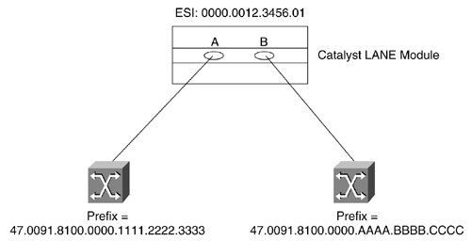
If A is the preferred port, the resulting NSAP is the following:
47.0091.8100.0000.1111.2222.3333.0000.0C12.3456.01
However, if the left-hand switch fails, the NSAP changes when the B port becomes active:
47.0091.8100.0000.AAAA.BBBB.CCCC.0000.0C12.3456.01
Although this change does not affect LANE Clients, it has a significant influence on LECS and LES/BUS configurations that use SSRP. In practice, this means that the LS1010 must list four LECS addresses to provide a single redundant LECS device. In addition, the LECS database must list four LES addresses to provide a single redundant LES/BUS.
Tip
Using SSRP with Dual-PHY connections generally requires careful planning of the order of SSRP entries.

For example, Figure 9-28 illustrates two LES/BUSs linked to two LS1010s through dual-PHY connections.

Figure 9-28 Redundant LES/BUSs Connected via Dual-PHY to Two ATM Switches
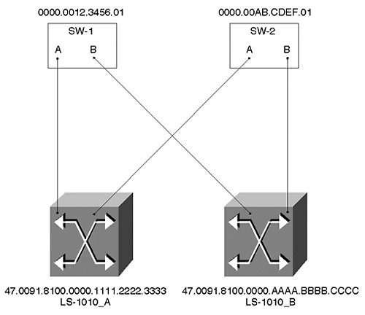
The LECS database should contain four name ELAN_NAME server-atm-address NSAP commands for each ELAN. Look at Example 9-18.

Example 9-18 Inefficient LECS Configuration for SSRP
name ELAN1 server-atm-address 47.0091.8100.0000.1111.2222.3333.0000.0C12.3456.01 name ELAN1 server-atm-address 47.0091.8100.0000.AAAA.BBBB.CCCC.0000.0C12.3456.01 name ELAN1 server-atm-address 47.0091.8100.0000.1111.2222.3333.0000.0CAB.CDEF.01 name ELAN1 server-atm-address 47.0091.8100.0000.AAAA.BBBB.CCCC.0000.0CAB.CDEF.01
Although this provides LES/BUS redundancy, it introduces another complication. Assume that both Catalysts are using PHY-A as the preferred link and LS-1010-A fails. The LECs instantly try to rejoin ELAN1 and be directed by the LECS to the second LES listed in the database, Port B on the SW-1. However, because this port has not completed its ILMI address registration process (when LS-1010-A failed, PHY-A went down with it and it typically takes about 10–15 seconds to bring up ILMI on another port), the call fails and the LECs try the third LES listed, Port A on SW-2. The call succeeds and all the LECs rejoin the ELAN. However, a few seconds later Port B on SW-1 completes the ILMI addresses registration process and becomes active. Now that the second LES in the database is active, Port A on SW-2 reverts to backup mode, causing all of the LECs to again be thrown out of the ELAN. When the LECs try again to rejoin, the LECS sends them to Port B on SW-1.
This unnecessary backtracking can be avoided by carefully coding the order of the LECS database as in Example 9-19.

Example 9-19 Coding the LECS Database Order
name ELAN1 server-atm-address 47.0091.8100.0000.1111.2222.3333.0000.0C12.3456.01 name ELAN1 server-atm-address 47.0091.8100.0000.1111.2222.3333.0000.0CAB.CDEF.01 name ELAN1 server-atm-address 47.0091.8100.0000.AAAA.BBBB.CCCC.0000.0C12.3456.01 name ELAN1 server-atm-address 47.0091.8100.0000.AAAA.BBBB.CCCC.0000.0CAB.CDEF.01
The configuration in Example 9-19 offers faster failover because the second device listed completes address registration before Port A on SW-1 fails. This allows the second LES to be immediately available without backtracking.

Using the Well-Known NSAP for LECS Discovery
Earlier in the chapter, the text mentioned that Cisco recommends using ILMI to pass the NSAP address of the LECS to the LECs. However, Cisco also supports using hard-coded NSAP addresses and using the well-known NSAP address. Because the well-known NSAP address is used in many networks (for example, it is the default method used on Fore Systems equipment), this section briefly looks at the configuration syntax and issues involved in using the well-known NSAP.
To configure use of the well-known NSAP, merely modify the command used to enable the LECS—use the lane config fixed-config-atm-address command as opposed to the lane config auto-config-atm-address command. The causes the LECS to register the 47.007900000000000000000000.00A03E000001.00 so that it can be made reachable via PNNI.
Example 9-20 illustrates a complete configuration that uses the well-known LECS NSAP and places all four LANE components for two ELANs on a single device.

Example 9-20 Using the Well-Known LECS NSAP
lane database WKN name ELAN1 server-atm-address 47.00918100000000102962E801.00102962E431.01 name ELAN2 server-atm-address 47.00918100000000102962E801.00102962E431.02 ! interface ATM0 atm preferred phy A atm pvc 1 0 5 qsaal atm pvc 2 0 16 ilmi lane config fixed-config-atm-address lane config database WKN ! interface ATM0.1 multipoint lane server-bus ethernet ELAN1 lane client ethernet 1 ELAN1 ! interface ATM0.2 multipoint lane server-bus ethernet ELAN2 lane client ethernet 2 ELAN2
One of the advantages of using the well-known NSAP is that it does not require any configuration at all on the LS1010 ATM switch. Because the LECs automatically try the well-known NSAP if the hard-coded NSAP and ILMI options fail, the LEC reaches the LECS with minimal configuration.
Although the well-known NSAP is potentially easier to configure in small networks, Cisco recommends the ILMI approach because it provides better support for SSRP server redundancy. There is a problem if multiple LECS servers try to use the well-known NSAP for LECS discovery: both servers try to register the same 47.0079… address! With ILMI and SSRP, every device registers a unique NSAP address, avoiding any PNNI routing confusion.
If you run into a situation where you need to run SSRP and also support the well-known NSAP (this can be the case if you are using third-party LECs that do not support the ILMI LECS discovery method), there is a solution. First, configure all of the LECS devices with the lane config fixed-config-atm-address command. Next, be sure to also configure every LECS for ILMI support with the lane config auto-config-atm-address command. This allows SSRP to function properly and elects only a single primary LECS. Because the backup LECS servers do not register the well-known NSAP, only the primary originates the 47.0079… route into PNNI. You now have the resiliency of SSRP combined with the simplicity and widespread support of the well-known NSAP!

PVCs and Traffic Shaping
The Catalyst LANE module allows connections to one or more Catalysts using PVCs. When implementing this, the LECS, LES, and BUS server functions are not utilized. You simply build a PVC and then bind a VLAN to that circuit as in Example 9-21.

Example 9-21 Catalyst ATM PVC Configuration
int atm 0 atm pvc 3 0 50 aal5snap atm bind pvc vlan 3 1
This creates a PVC using VPI 0 and VCI 50 and then binds it to VLAN 1. PVCs can be useful in small networks, especially when connecting two Catalyst LANE blades back-to-back without using an ATM switch. Another advanced feature offered by the Catalyst is PVC-based traffic shaping. This allows you to set a peak bandwidth level on a particular circuit. It can be very useful for controlling bandwidth across expensive wide-area links. This feature requires you to load a special image into flash on the LANE module and does not work with SVCs. For example, Example 9-22 adds traffic shaping to the configuration in Example 9-21.

Example 9-22 Traffic Shaping and ATM PVCs
int atm 0 atm pvc 3 0 50 aal5snap 11000 atm bind pvc vlan 3 1
The final parameter on the atm pvc command limits the traffic to a peak rate of 11 Mbps.

Exercises
This section includes a variety of questions and hands-on lab exercises. By completing these you can test your mastery of the material included in this chapter as well as help prepare yourself for the CCIE written and lab tests.

Review Questions
1: | What are the three layers of the ATM stack? What does each do?
2: | What is the difference between ATM and SONET?
3: | What is the difference between a Catalyst with two LANE modules and a two-port ATM switch?
4: | What is the difference between a VPI, a VCI, and an NSAP? When is each used?
5: | Assume you attached an ATM network analyzer to an ATM cloud consisting of one LS1010 ATM switch and two Catalysts with LANE modules. What types of cells could you capture to observe VPI and VCI values? What type of cells could you capture to observe NSAP addresses?
6: | What are the three sections of an NSAP address? What does each part represent?
7: | How do Catalysts automatically generate ESI and selector byte values for use with LANE?
8: | What is the five-step initialization process used by LANE Clients to join an ELAN?
9: | What are the names of the six types of circuits used by LANE? What type of traffic does each carry?
10: | What is the difference between an IP ARP and an LE_ARP?
11: | In a network that needs to trunk two VLANs between two Catalysts, how many LECs are required? How many LECSs? How many LESs? How many BUSs?
12: | If the network in Question 12 grows to ten Catalysts and ten VLANs, how many LECs, LECSs, LESs and BUSs are required? Assume that every Catalyst has ports assigned to every VLAN.
13: | Trace the data path in Figure 9-26 from an Ethernet-attached node in VLAN 1 on Cat-A to an Ethernet-attached node in VLAN 2 on Cat-B. Why is this inefficient?

Hands-On Lab
Build a network that resembles Figure 9-29.

Figure 9-29 Hands-On Lab Diagram
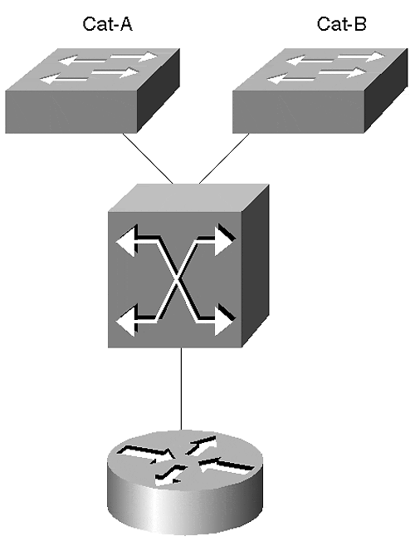

Table 9-6 shows the LANE components that should be configured on each device.

Table 9-6. LANE Components to Be Configured
Device | VLAN1/ELAN1 | VLAN2/ELAN2 | VLAN3/ELAN3
LEC-A | LEC, LES/BUS | LEC | LEC
LEC-B | LEC | LEC, LES/BUS | LEC
Router | LEC | LEC | LEC, LES/BUS
LS1010 | LEC | LEC | LEC
The LS1010 is the LECS.
Configure IP addresses on the SC0 interfaces of both Catalysts, the router subinterfaces, and the LS1010 subinterfaces (use interface atm 2/0/0 or 13/0/0 for the LS1010). Configure HSRP between the ATM router and an RSM located in LEC-A. Table 9-7 provides IP addresses that can be used.

Table 9-7. IP Addresses for Hands-On Lab
Device | VLAN1/ELAN1 | VLAN2/ELAN2 | VLAN3/ELAN3
LEC-A SC0 | 10.1.1.1
LEC-A RSM | 10.1.1.252 | 10.1.2.252 | 10.1.3.252
LEC-B SC0 | 10.1.1.2
Router | 10.1.1.253 | 10.1.2.253 | 10.1.3.253
LS1010 | 10.1.1.110 | 10.1.2.110 | 10.1.3.110
HSRP Address | 10.1.1.254 | 10.1.2.254 | 10.1.3.254
When you are done building the network, perform the following tasks:
- Test connectivity to all devices.
- Turn on debug lane client alland ping another device on the network (you might need to clear the Data Direct if it already exists). Log the results.
- With debug lane client all still running, issue shut and no shut commands on the atm major interface. Log the results.
- Examine the output of the show lane client, show lane config, show lane server, show lane bus, and show lane databasecommands.
- Add SSRP to allow server redundancy.
- If you have multiple ATM switches, add dual-PHY support (don't forget to update your SSRP configurations).

